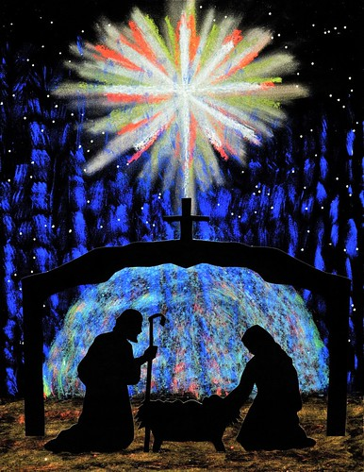
Welcome to worship!

December 24, 2020, 7:00 pm

Christmas Eve

A joint online Zoom worship Service with:

Claremont, Fairbank & Goodwood

United Churches and friends.

Worship Leaders:

Pastor Steven Loweth, DLM

& Rev. Lionel Ketola, BA, M Div.

Onelicense # A-723979 CCLI # 11550809

Welcome

As we begin our worship on this holy night
we acknowledge the sacredness of the land where we worship tonight,
and the First Nations who are the traditional custodians of this land.
May the child of peace whose birth we celebrate transform all of our relations. Amen.

We Joyfully Gather in God’s Presence

Centering Words Adapted, from a prayer by Roddy Hamilton.

It is ancient -
as old as the first word ever spoken by God.

The sound of this word
has taken many forms through the ages,
but it speaks of a single truth -
a truth that beats at the very heart of God.

Some hear it beating swords into ploughshares.
Others hear it hammering spears into pruning hooks.
Others hear it as a newborn child’s cry, inviting us into a new reality.
It is the first word that God uttered
when God began creating stars and galaxies in breathtaking wonder and beauty.
A word that would begin it all:
Love.

Opening Song: It Came Upon the Midnight Clear VU # 44

Prayer of the Day Adapted, from Prayers for an Inclusive Church, p. 3

God of hope and expectation:
In a time of empires
your Word was born to those
who have no place
and sung to those
who have lost all hope.
May this birth unsettle our world
with hidden glory
and untold peace;
through Jesus Christ, the Child of Promise. Amen.

Lessons and Carols for Christmas Eve
Narrated by Harper Forbes

The Annunciation

Carol: The Angel Gabriel from Heaven Came Video

The Angel appears to Joseph

Carol: Angels from the Realms of Glory VU # 36

The Birth of Christ

Carol: Away in a Manger VU # 69 (Tune: VU 6, Away In A Manger)

The Angel appears to the Shepherds

Carol: While Shepherds Watched Their Flocks VU # 75

The Visit of the Magi

Carol: What Child is This VU # 74

The Escape to Egypt

Music: The Coventry Carol Video

The Return from Egypt

Carol: Hark the Herald Angels Sing VU # 48

Invitation to the Offering
Sung Offering Verse: VU # 55

What can I give him, poor as I am?
If I were a shepherd, I would bring a lamg.
If I were a wise man, I would do my part, yet
what can I give him – give my heart.

Offering Prayer

God of love,
as we kneel before the cradle of your mystery
what gift can we offer
but to open up our hearts
and let your love
reshape our very lives.
May the gifts that we offer this night
bring healing and hope to our aching world.
We pray in Jesus’ name. Amen.

Prayers of the People
Joining our voices with the song of the angels, let us pray for the church, the world, and all who are in need.
A brief silence.

The shepherds sing, “Jesus Christ is born!” Let your church throughout the world proclaim this good news, over the hills and everywhere. Unite the voices of all your faithful people in songs of praise and rejoicing.
God in your love, Hear our prayer.

Heaven and nature sing, “Joy to the world!” Give respite to flocks, fields, and those who tend them. Come near to us in the beauty of nighttime, the shining of the stars, and the hush of a world at rest. May our wonder at your creation rouse our care for all the earth.
God in your love, Hear our prayer.

The angels sing, “Peace on earth!” Come quickly to still the strife of this world. Hush the noise of war and violence in places of unrest (especially). Inspire leaders of nations to seek lasting peace and sustainable provision for all in their care.
God in your love, Hear our prayer.

Mary sings melodies of comfort to her newborn child. Bring rest and reassurance to those facing struggles this night. Shelter travelers and those without homes. Console those who lie awake due to pain or anxiety. Heal those who are sick or hurting.
God in your love, Hear our prayer.

Love sings through the sound of a new baby’s cry. Bless new parents and expectant parents. Comfort those who long for children, especially those running out of hope or options. Surround families of every shape and size with your love and care.
God in your love, Hear our prayer.

We give thanks for the congregations of Claremont, Fairbank and Goodwood United Churches, as we all journey together in this time of pandemic. May the celebration of Christ’s birth fill our hearts with the hope and joy that comes from knowing that you are with us. God in your love, Hear our prayer.

At this time, we pause to lift up – in the silence of our hearts – all those who are in our prayers this holy night…. (prayers are now offered in silence)
God in your love, Hear our prayer.

The heavenly chorus sings, “Glory to God in the highest!” We give you thanks for all the saints who have proclaimed your glory in word and deed. Let us join them this night in joyful praise in your loving presence.
God in your love, Hear our prayer.

God of mercy, come quickly to us with grace upon grace as we lift these and all our prayers to you, in the name of Jesus.
Amen.

With our Saviour Christ we pray: “God our Mother and Father in Heaven …”

Blessing and Commissioning

On this holy night,
may the eagerness of the Shepherds,
the joy of the angels,
the wonder of the Magi,
the faithfulness of Joseph and Mary,
and the love of the Child of Peace be yours.

And may the blessing of God:
Creator, Christ and Holy Spirit
be with you now and always. Amen.

Carol: Silent Night Alex Hyunh Do

Dismissal:
Go in Peace. Share the Angel’s song!
Thanks be to God!

Thank you to our musicians for tonight
From Claremont United Church: Gabrielle Untermann, Jane Plewman, Julia Shatford, Barb Gilbert and Steve May; otherwise known as “The Masked Bandits”.
From Fairbank United Church: Alex Hyunh Do, Mary Slate & Kelly Slate.

Have a Blessed Christmas!

