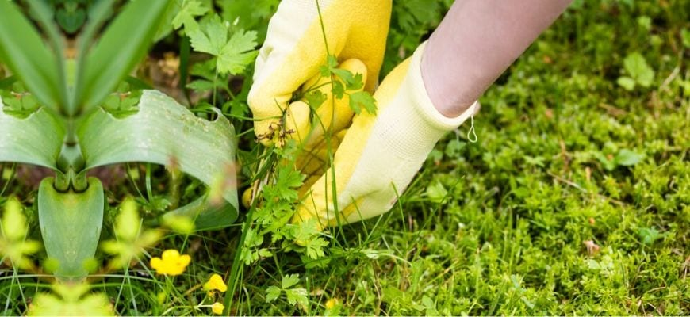

***Welcome to worship!***

**Sunday July 19, 2020**

**7th Sunday after Pentecost**

**Holy Commuion**

***A joint online Zoom worship Service with:***

***Claremont, Fairbank & Goodwood United Churches and Guests***

***Worship Leaders:*** *Pastor Steven Loweth & Rev. Lionel Ketola*

Onelicense # A-723979 CCLI # 11550809

**Announcements & Today’s Worship Theme**

**We Gather to in Joyful Celebration**

**Lighting the Christ Candle**

There was a man named Jesus, who embodied God’s love and compassion in such surprising ways. And he said: **I am the light of the world**

**Acknowledgement of the Land**

As we begin our worship, we acknowledge the traditional custodians of the land where each of us are gathered today. We pay my respects to the Elders past, present and emerging, for they hold the memories, the traditions, the culture and the hopes of all Indigenous peoples on Turtle Island.

**God of justice, help us to embody your call to reconciliation with our First Nations in tangible, loving ways. Amen.**

**Call to Worship**

We come to celebrate God’s blessings to us.

**Surely God is in this place!**

We come to open ourselves to God’s guidance and love.

**Surely God is in this place!**

We come to see more clearly God’s presence in our lives.

**Surely God is in this place!**

We come to see God in this community of seekers.

**Surely God is in this place!**

We come to pray, praise, and offer ourselves to God.

**Surely God is in this place! Let us worship!**

**Prayer of the Day**

**O God,**

**We gather together in Your presence with expectation,**

**hungry for an encounter with You,**

**eager to hear Your Word.**

**Open our eyes and ears to the presence of Your Holy Spirit.**

**May the seeds of Your Word scattered among us this morning**

**fall on fertile soil.**

**May they take root in our hearts and lives,**

**and produce an abundant harvest**

**of good words and deeds.**

**We pray this in the name of Jesus Christ,**

**our teacher and our Lord.**

**Amen.**

**Opening Hymn: Open my Eyes that I may See VIDEO**

Prayer of Confession

Merciful God,

you plant each of us like seeds in the same field and together we are nourished and nurtured by the sun.  We sway in the wind and are refreshed by the rain. We are blessed by the knowledge that you want us to grow towards what you call us to be.

When we deprive others of that same opportunity,  
**forgive us.**

When we want to uproot those whom we believe

do not belong in our part of the field,  
**forgive us.**

When we label others as good or bad

rather than accept them for who they are,  
**forgive us.**

When we are reluctant to acknowledge

that we ourselves are a mixture of weeds and wheat,  
**forgive us.**

When we are afraid to look into the fields of our own lives

to see what is growing there,  
**forgive us.**

O God, you know us inside and out, through and through.  
**You search us out and lay your hand upon us**.  
You know what we are going to say even before we speak.  
**So we pray that you will help us to reach out to the uprooted and rejected,**  
the lonely and the outcast,  
**and to develop and grow the good in ourselves, in others and in our world.**

**This we pray in Jesus’ name.  Amen**

Assurance of Forgiveness

People of God,

even in the times in which the chaos of life sweeps you away from the peace of God,

know that God is there, waiting patiently,

for you to come back to the quiet centre.

God loves you - just as you are, and you are forgiven.

And in that forgiveness, you are set free! Amen!

**We Open our Hearts to the Spirit’s Voice**

One: Whether you take what is written in the Bible as fact, metaphor, myth or story, listen now to these words for the meaning they hold in your lives today.

**All: May the Spirit bless us with wisdom and wonder, as we ponder the meaning of these words in our lives.**

**Genesis 28:10-19**

10Jacob left Beer-sheba and went toward Haran. 11He came to a certain place and stayed there for the night, because the sun had set. Taking one of the stones of the place, he put it under his head and lay down in that place. 12And he dreamed that there was a ladder set up on the earth, the top of it reaching to heaven; and the angels of God were ascending and descending on it. 13And the Lord stood beside him and said, “I am the Lord, the God of Abraham your father and the God of Isaac; the land on which you lie I will give to you and to your offspring; 14and your offspring shall be like the dust of the earth, and you shall spread abroad to the west and to the east and to the north and to the south; and all the families of the earth shall be blessed in you and in your offspring. 15Know that I am with you and will keep you wherever you go, and will bring you back to this land; for I will not leave you until I have done what I have promised you.”

16Then Jacob woke from his sleep and said, “Surely the Lord is in this place—and I did not know it!” 17And he was afraid, and said, “How awesome is this place! This is none other than the house of God, and this is the gate of heaven.” 18So Jacob rose early in the morning, and he took the stone that he had put under his head and set it up for a pillar and poured oil on the top of it. 19He called that place Bethel; but the name of the city was Luz at the first.

**Reflection: Rev. Lionel Ketola**

**Gospel Acclamation VIDEO**

**Matthew 13:24-30, 36-43**

24He put before them another parable: “The kingdom of heaven may be compared to someone who sowed good seed in his field; 25but while everybody was asleep, an enemy came and sowed weeds among the wheat, and then went away. 26So when the plants came up and bore grain, then the weeds appeared as well. 27And the slaves of the householder came and said to him, ‘Master, did you not sow good seed in your field? Where, then, did these weeds come from?’ 28He answered, ‘An enemy has done this.’ The slaves said to him, ‘Then do you want us to go and gather them?’ 29But he replied, ‘No; for in gathering the weeds you would uproot the wheat along with them. 30Let both of them grow together until the harvest; and at harvest time I will tell the reapers, Collect the weeds first and bind them in bundles to be burned, but gather the wheat into my barn.’”

36Then he left the crowds and went into the house. And his disciples approached him, saying, “Explain to us the parable of the weeds of the field.” 37He answered, “The one who sows the good seed is the Son of Man; 38the field is the world, and the good seed are the children of the kingdom; the weeds are the children of the evil one, 39and the enemy who sowed them is the devil; the harvest is the end of the age, and the reapers are angels. 40Just as the weeds are collected and burned up with fire, so will it be at the end of the age. 41The Son of Man will send his angels, and they will collect out of his kingdom all causes of sin and all evildoers, 42and they will throw them into the furnace of fire, where there will be weeping and gnashing of teeth. 43Then the righteous will shine like the sun in the kingdom of their Father. Let anyone with ears listen!

**Reflection: Pastor Steven Loweth**

**We Joyfully Respond to the Good News**

**Hymn of the Day: Come and Find the Quiet Centre VIDEO**

**Invitation to the Offering**

**Prayer of Dedication for the Gifts**

What mysteries there are in God’s world!

**We, so sophisticated, stand in awe at the wonders of the natural world.**

We look at the tiniest of seeds and wonder what will happen

**From that small seed will grow a large shrub.**

Although we consider our gifts to be small and insignificant,

**God will use our gifts in miraculous ways.**

**Praise the God of small seeds and mighty power. Amen.**

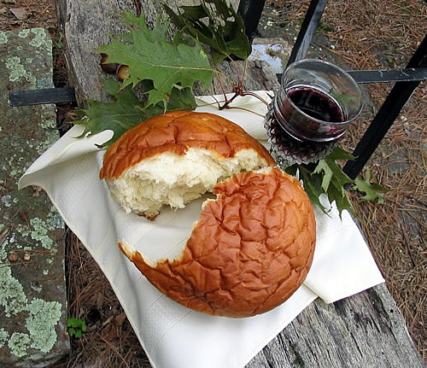**A Summer Communion Service**

God of Summer’s abundant life,

happy are those who delight in you

**They are like trees planted**

**by streams of water,**

**bearing good fruit in season.**

How precious is your steadfast love, O God!

**All people find refuge**

**in the shadow of your wings!**

**They feast on the abundance of your house;**

**You give them drink from the river of your delights.**

**For with you is the fountain of life!**

You filled creation with life.

Your prophets called your people to walk in the way of justice and integrity.

Jesus came to draw us into your deep, abundant life!

And so with all who have rooted their lives in the soils of your great love,

we join in their happy song: (*VU # 951, v 2, “Santo, Santo, Santo”)*

**Holy, Holy, holy, My heart, my heart adores you!**

**My heart is glad to say the words: You are holy, God!**

Jesus our brother, you came to restore our life to its beauty and fullness -

**In his life and ministry ushering in God’s Reign - new life!**

**In his triumph over death – new courage and hope!**

**In the promise of his coming again – new vision and purpose!**

We remember that on the night that Jesus was betrayed …

**L**oving God, with this bread and cup, we dedicate our lives

to the care and redemption of your beloved creation.

**Send now your life-giving Spirit upon us and these gifts of bread and wine.**

**Empower our faithful witness to your reign of love and justice!**

Healing God, as we gather at your table of life,

we remember the needs of our community and our world … (prayers of intercession)

With Jesus, who showed us God’s Mothering love, we pray: ***“Our Father …”***

*At the breaking of the bread:*

Holy things for holy people

**Thanks be to God! Amen!**

**Prayer after Communion by Mary Jo Leddy**

**You are the hope in spite of ourselves,**

**the Love ever unforeseen,**

**the well of faith**

**in the centre of the world**

**in the middle of the day.**

**You are the way**

**the life-long Lifeline**

**long beyond life.**

**You are the Life in our living,**

**pushing us, pulling us,**

**pointing us all in Your direction.**

**For this we give you thanks. Amen.**

**Closing Hymn: Be Thou My Vision VIDEO**

**Blessing and Commissioning**

As we leave this place,

we know God will be with us wherever we go.

At work or play, at home or on vacation,

we know God will be with us wherever we go.

Whether we’re happy or sad, on our own, or with our friends,

we know God will be with us wherever we go.

So let’s go in joy with Our God who Creates

The Christ who guides us

And the Spirit who empowers us! **Amen!**

**Sung Blessing: “The Blessing: Canada” VIDEO**

**Next Sunday’s Readings:**

**July 26 – Eighth Sunday after Pentecost / Proper 12**

[Genesis 29:15-28](http://www.textweek.com/pentateuch/gen29.htm) Jacob marries Leah and Rachel

[Psalm 105:1-11, 45b](http://www.textweek.com/writings/psalm105.htm)  Make known what God has done

[Romans 8:26-39 The Spirit intercedes for us when we cannot pray](http://www.textweek.com/pauline/rom8d.htm)[Matthew 13:31-33, 44-52](http://www.textweek.com/mtlk/matt13c.htm) Five parables of Jesus: mustard seed, yeast, treasures, pearls, net.

***ANNOUNCEMENTS***

**Online Zoom Book Study Group (Claremont & Goodood United**): This coming Friday at 10:00 am is our last weekly book study session for Rev. Lenny Duncan’s book: “Dear Church: A Love Letter from a Black Preacher to the Whitest Denomination in the U.S.” which addresses the theme of anti-racism.

If there is interest, Rev. Lionel will host a fall session of this book reading group for those who haven’t had a chance to read it yet. So now is your chance to boorow or buy a copy of Lenny’s book and to join us for the Fall book study group.

**Joint Committee on Church Re-Opening (Goodwood and Claremont):** Wednesday, at 6:30 pm.

**Goodwood United Church: Online Check-in: Tuesdays at noon, on Zoom.** Once our check in time has come to a conclusion, the group will proceed with our weekly Bible Study / “Conversations about Life”, so feel free to join us for this as well.

**Claremont United Church: Wednesdays @ 12:00 noon - Join us for a Zoom drop in meeting** Everyone is invited to join us for these “virtual Brock Café” gatherings to connect with each other and check in with our congregational community.



**Continued Support for our Congregations**

Please prayerfully consider how you can continue to support your congregation’s ongoing ministries during this time.

* Offerings can be **mailed to the church address** itself
* **PAR forms** (for pre-authorized debit) are available from your church treasurer
* You can send your offering by **E-TRANSFER** through your bank. *next page.*

For e-transfers to **Claremont United,** sent it to: treasurercuc@outlook.com

For e-transfers to **Goodwood United**, send it to: [goodwooductreasurer@gmail.com](mailto:goodwooductreasurer@gmail.com)

***Thank you for your continued support of our congregation’s ministry.***

****Find us online! Check out our websites!**

Check out our church websites for **new updates** during this time, including Sunday devotions, and information about coping with stress during COVID-19.

[www.claremontunitedchurch.com](http://www.claremontunitedchurch.com)

[www.goodwoodunitedchurch.com](http://www.goodwoodunitedchurch.com)



**Find us on Facebook!**

<https://www.facebook.com/goodwoodunited>

<https://www.facebook.com/claremontunited>