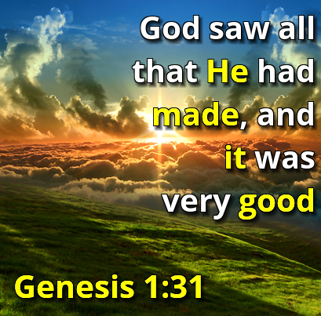
Welcome to Worship!
Sunday June 13, 2021, 10:30 am
3rd Sunday after Pentecost
Claremont, Fairbank & Goodwood United Churches
Join us on Zoom or our YouTube channel: CFG Worship
Worship Leaders:
Rev. Lionel Ketola, and Pastor Steven Loweth
OneLicense # A-723979 CCLI # 11550809

Week 6 of our Julian of Norwich Sermon Series:
“Trusting our Sensuality”

Words of Welcome

Introit: “Julian of Norwich” Linnea Good
Lighting the Christ Candle
There was a man named Jesus, who brought healing and new life to all whom he met.
And he said “I am the light of the World”.

Acknowledgement of the Land
As we begin our worship, we acknowledge the history, spirituality and cultures of the First Nations who are the traditional custodians of the land where each of us is gathered today. Their relationship with the land remains central to their lives.
God of new life, ground us in love and justice so we can work toward reconciliation and fulfill our treaty obligations with Canada’s First Nations peoples. Amen.

Opening Hymn: VU 291 All Things Bright and Beautiful

Prayer of the Day by Lionel Ketola

Extravagant God,
In love and delight you created us, and all that exists,
and you placed us in a diverse web of creation that you called: “very good!”

May our hearts overflow with gratitude for the goodness of who we are:
our physical selves,
our senses,
our intellect,
our spirituality,
our sexuality,
our creative capacities,
our ability to love and be in relationship,
and our place in creation.
All of these gifts you have woven into a holy whole.

May our gratitude overflow into acts of compassion and justice.
May we be tender lovers, joyful celebrants, and fierce advocates
for the web of creation in which we live, love and have our being.
We ask this in Jesus’ name, your Word of Life made Flesh. Amen.

We Gather Around God’s Word

One: Whether you take what is written in the Bible as fact, metaphor, myth or story, listen now to these words for the meaning they hold in your lives today.
All: May the Spirit bless us with wisdom and wonder, as we ponder the meaning of these words in our lives.

Psalm 139
¹O Lord, you have searched me and known me.
²You know when I sit down and when I rise up; you discern my thoughts from far away.
³You search out my path and my lying down, and are acquainted with all my ways.
⁴Even before a word is on my tongue, O Lord, you know it completely.
⁵You hem me in, behind and before, and lay your hand upon me.
⁶Such knowledge is too wonderful for me; it is so high that I cannot attain it.

¹³For it was you who formed my inward parts; you knit me together in my mother’s womb.
¹⁴I praise you, for I am fearfully and wonderfully made. Wonderful are your works; that I know very well.
¹⁵My frame was not hidden from you, when I was being made in secret, intricately woven in the depths of the earth.
¹⁶Your eyes beheld my unformed substance. In your book were written all the days that were formed for me, when none of them as yet existed.
¹⁷How weighty to me are your thoughts, O God! How vast is the sum of them!
¹⁸I try to count them—they are more than the sand; I come to the end—I am still with you.

Scripture Hymn: MV # 85 Take, O Take Me As I Am
https://youtu.be/bv4f-8L1uk0

Genesis 1:1-5, 26-31.

In the beginning when God created the heavens and the earth, ²the earth was a formless void and darkness covered the face of the deep, while a wind from God swept over the face of the waters.
³Then God said, “Let there be light”; and there was light. ⁴And God saw that the light was good; and God separated the light from the darkness. ⁵God called the light Day, and the darkness he called Night. And there was evening and there was morning, the first day.
²⁶Then God said, “Let us make humankind in our image, according to our likeness; and let them have dominion over the fish of the sea, and over the birds of the air, and over the cattle, and over all the wild animals of the earth, and over every creeping thing that creeps upon the earth.” ²⁷So God created humankind in his image, in the image of God he created them; male and female he created them. ²⁸God blessed them, and God said to them, “Be fruitful and multiply, and fill the earth and subdue it; and have dominion over the fish of the sea and over the birds of the air and over every living thing that moves upon the earth.”
²⁹God said, “See, I have given you every plant yielding seed that is upon the face of all the earth, and every tree with seed in its fruit; you shall have them for food. ³⁰And to every beast of the earth, and to every bird of the air, and to everything that creeps on the earth, everything that has the breath of life, I have given every green plant for food.” And it was so.
³¹God saw everything that he had made, and indeed, it was very good. And there was evening and there was morning, the sixth day.

Holy Wisdom, Holy Word Thanks be to God!

Sermon: Pastor Steven Loweth

Hymn of the Day: MV # 157 I am a Child of God
https://youtu.be/RKs1mJDkwkI

Affirming Moment Video – Blessing of Claremont United Church’s rainbow bench

Invitation to the Offering

Prayer of Dedication for the Gifts
Generous God, through the diverse web of creation,
You have blessed us with the gifts of abundant life.
May the gifts that we offer
help bring our world to blossom with healing, hope, and abundant life;
through Christ, the Tree of Life. Amen.

Prayers of the People
God of abundant life,
From Day One,
your Spirit brooding over the deep,
your wind rushing, your breath filling.
As creatures of the earth,
we inhale your grace,
rejoicing in life abundant.
We use our breath, our being
to raise this hymn of praise:
Hallelujah to the sun’s hot passion
embracing the ground’s great shoulders!
Hallelujahs for the growth from seed to plant
greening the earth; its fruit—beauty and food!
Hallelujahs for generations of life
tumbling one after another,
life creeping, swimming, flying, running,
below, above, upon, within.
All the world sings, calls, signals, speaks
praise to God whose glory grows in all that breathes!
Fill us, enliven us to be ambassadors of life divine,
breathing out your song in harmony,
singing to our Creator,
whose Holy Spirit is unending, ageless, eternal and ever new.

God of abundant life, hear our prayer.

We remember our Muslim sisters and brothers in our prayers today, especially all who mourn the death of 9 year old Fayez’s mother, father, sister and grandmother, in London Ontario, and for all , and we pray for all who traumatized by this event and who are fearing for their safety due to their Muslim faith.
God of abundant life, hear our prayer.

We continue to pray for Indigenous communities across Canada who continue to grieve the news of the deaths of 215 residential school children, and we pray that the Spirit will move us to seek justice and reconciliation.
God of abundant life, hear our prayer.

We pray for healthcare workers, frontline workers and all who are struggling with isolation and mental health concerns during this pandemic. As our Province moves into stage 1 of reopening, we give thanks for lower new infection numbers and new freedoms gained. Fill us with hope at this time, and help us to continue caring for the health and safety of one another.
God of abundant life, hear our prayer.

At this time, we remember all who have asked for our prayers.

Intercessions are offered

Into your hands, Creating God, we commend all for whom we pray, trusting in Jesus who taught us to pray:
God, our Mother and Father in heaven…….

Closing Song: MV # 30 It’s a Song of Praise to the Maker
https://youtu.be/ooHrGu2S5KU

Blessing: Based on Psalm 139

As we go forth, let’s not forget:
There is nowhere we can go where God is not.
Everywhere we go, God’s love journeys with us.
From the farthest ocean to the highest mountain,
from the heights of joy to the depths of despair—
wherever we find ourselves, God’s grace and support are already there.
So go in peace, for we do not go alone.
And may the blessing of God,
Creator, Christ and Holy Spirit journey with us - now, and always. Amen.

Sung Dismissal: Go Now in Peace CFG Worship Choir

Church Announcements

… see the pages below

Upcoming Worship Services

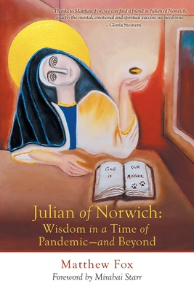
Julian of Norwich: Wisdom in a time of Pandemic
A Sermon Series
based on the book by Matthew Fox
Our 7 week Sermon Series based on Matthew Fox’s book continues. After the series is complete you may enjoy ordering the book to reflect further on it. Each service and Sermon will be posted on our YouTube Channel for viewing later. CFG Worship available here Channel content - YouTube Studio

June 13 – Week 6 “Trusting our Sensuality”
Preacher: Pastor Steve
Scriptures: Psalm 139: 1-6 13-18, Genesis 1: 1-5, 26-31.

June 20 – Week 7 “The Power of Love over Evil”
(Father’s Day, and Indigenous Day of Prayer)
HOLY COMMUNION
Preaching: Rev. Lionel & Pastor Steve
Scriptures: Psalm 98, John 15:9-17

June 27 Pride Sunday Service

July 4 – Week 8 “Why Julian? Why Now?” (Conclusion of our Julian Series)
SERVICE OF ANOINTING AND HEALING
Preaching: Rev. Lionel & Pastor Steve
Scriptures: TBA

July 11 Country & Western Theme Summer Service
HOLY COMMUNION
Send us your hymn requests!
Email Pastor Steve or Rev. Lionel with
your “requests” for any country music
hymns that you’d like us to include in
this service. It will be a fun, musical service with Holy Communion.
Goodwood United Church - Weekly Programs & Meetings

The Knit-Wits: Wednesdays at 10:00 am. This is Goodwood United Church’s weekly ZOOM group for Knitting, crochet and other needle craft. This group facilitates our congregation’s Prayer Shawl Ministry. They will keep you in stitches! To find out how to connect with this group on Zoom, contact Shirley Baster.

Online Community Check-in: Thursdays at 10:30 AM, on Zoom. Join us for an opportunity to connect and find supportive community through our regular weekly check-in meetings. At the conclusion of our check-in time, we move into our weekly “Conversations about Life / Not your Typical Bible Study” group. Feel free to join us!

Book Study: Resumes Friday June 4 at 10:00 am on Zoom – See Below for details of our new book study below.

Claremont United Church - Weekly Programs and Meetings

During June we will meet Wednesdays @ 10:00 am – Join us for our weekly Zoom “drop-in” meeting. Everyone is invited to join us for these “Virtual Brock Café” Zoom gatherings to connect with our Claremont United Church community. Enjoy catching up with each other and sharing support.

SPECIAL CONGREGATIONAL MEETING: WED JUNE 23, 7:30 PM
Join us for this special congregational meeting which has been called by the Board of Claremont United Church. The purpose of this meeting is to vote on whether we would like to become an official Affirming Congregation, and become Public, Intentional and Explicit about our welcome to 2SGLBTQ+ people.

DISCERNMENT PROCESS – CLAREMONT UNITED CHURCH’S FUTURE
At its last meeting, Claremont United Church’s Board has voted to begin a Discernment process which will use the “wisdom circle process” to discern what our future as a congregation could look like! This is a very exciting process to begin, as we seek the Spirit’s guidance in our reflections and discernment about our future shape & ministries.
This process will begin in the FALL of 2021, to give us a little time for a summer break as things (hopefully) open up this summer.

Join us for Worship on our YouTube channel - CFG Worship
- Join us for worship either on Zoom, or on YouTube, Sundays at 10:30 am
- Watch past services uploaded to our YouTube channel
Go to Youtube.com and search CFG Worship.

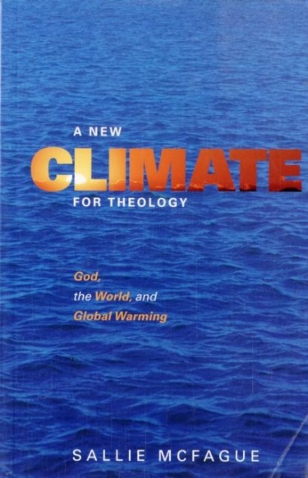
Join our BOOK STUDY GROUP
for all 3 Churches & friends:
Each Friday at 10:00 am on Zoom
We are reading our new book:
A New Climate for Theology:
God, the World, and Global Warming,
by Sallie McFague. It is an excellent book, so please join us!!
The book is available locally from Blue Heron in Uxbridge, if you don’t want to have to rely on the ‘big box’ online stores… so order yours now!

Continued Financial Support for our Congregations
Please prayerfully consider how you can continue to support
your congregation’s ongoing ministries during this time.
- Offerings can be mailed to the church address itself
- PAR forms (for pre-authorized debit) are available from your church treasurer
- You can send your offering by E-TRANSFER through your online banking. Here is where to send them:
For Claremont United send to: treasurercuc@outlook.com
For Goodwood United send to: goodwooductreasurer@gmail.com
Thank you for your continued support of our congregation’s ministry.

