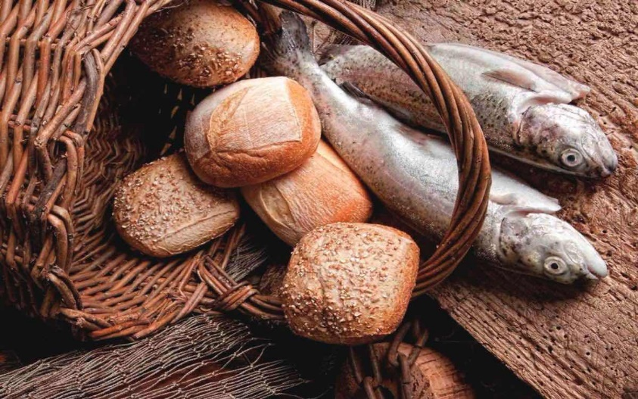
Welcome to worship!

Sunday Aug 2, 2020

9th Sunday after Pentecost

A joint online Zoom worship Service with:

Claremont, Fairbank & Goodwood United Churches and Guests

Worship Leaders:

Pastor Steven Loweth & Rev. Lionel Ketola

Onelicense # A-723979 CCLI # 11550809
Announcements & Today’s Worship Theme

We Gather to in Joyful Celebration
Lighting the Christ Candle
There was a man named Jesus, who embodied God’s love and compassion in such surprising ways. And he said: I am the light of the world

Acknowledgement of the Land
As we begin our worship, we acknowledge the traditional custodians of the land where each of us are gathered today. We pay my respects to the Elders past, present and emerging, for they hold the memories, the traditions, the culture and the hopes of all Indigenous peoples on Turtle Island.
God of justice, help us to embody your call to reconciliation with our First Nations in tangible, loving ways. Amen.

Call to Worship
Here we are as disciples:
learners along the Way, mentored by Rabbi Jesus
We are here as apostles
“Sent out ones” commissioned by Jesus, to share the good news of God’s love.
We are here to join followers of Jesus from every generation
With them, we worship today, open to the Spirit’s voice.

Prayer of the Day
God of compassion,
whose heart goes out to the hungry and destitute;
You take our lack, and transform it into much.
Give us the bread that satisfies,
the food without price,
that our lives may be freed to share your overflowing love;
through Jesus Christ, the breaker of bread. Amen.

Opening Hymn: Come my Way my Truth My Life VU # 628 VIDEO

Brief Order of Confession and Forgiveness
Blessed be God:
Creator of sun and rain, field and ocean,
Bread of Life from Heaven,
Wind of the Spirit, at work in us and in our world.
All: Amen.

Jesus said: “You shall love the Lord your God with all your heart, with all your soul, and with all your mind”. This is the greatest and most important commandment. The second is like it: You shall love your neighbour as yourself. The whole law of Moses and the teachings of the prophets depend on these two commandments”.
God, we have sinned against You, our neighbours, and your creation, by what we have done, and by what we have left undone. Have mercy on us.

(Silence for reflection and self-examination.)

We pray together:
Gracious God, forgive us, renew us, and lead us,
so we may delight in your will, and walk in your Way. Amen.

God, who is rich in mercy, loves us unconditionally.
God’s grace and forgiveness are a free gift, lavished upon us.
If anyone is in Christ, they are a new creation.
In the name of Jesus Christ, your sins are forgiven.
May God strengthen and renew you
and fill you with new life through the Spirit’s power.
All: Amen.

We Open our Hearts to the Spirit’s Voice

One: Whether you take what is written in the Bible as fact, metaphor, myth or story, listen now to these words for the meaning they hold in your lives today.
All: May the Spirit bless us with wisdom and wonder, as we ponder the meaning of these words in our lives.

First Reading: Genesis 32:22-31
²²The same night he got up and took his two wives, his two maids, and his eleven children, and crossed the ford of the Jabbok. ²³He took them and sent them across the stream, and likewise everything that he had.
²⁴Jacob was left alone; and a man wrestled with him until daybreak. ²⁵When the man saw that he did not prevail against Jacob, he struck him on the hip socket; and Jacob’s hip was put out of joint as he wrestled with him. ²⁶Then he said, “Let me go, for the day is breaking.” But Jacob said, “I will not let you go, unless you bless me.” ²⁷So he said to him, “What is your name?” And he said, “Jacob.” ²⁸Then the man said, “You shall no longer be called Jacob, but Israel, for you have striven with God and with humans, and have prevailed.” ²⁹Then Jacob asked him, “Please tell me your name.” But he said, “Why is it that you ask my name?” And there he blessed him. ³⁰So Jacob called the place Peniel, saying, “For I have seen God face to face, and yet my life is preserved.” ³¹The sun rose upon him as he passed Penuel, limping because of his hip. Holy Wisdom, Holy Word Thanks be to God
Reflection: Rev. Lionel
Scripture Song: Just As I Am VU # 508 VIDEO
Just as I am, without one plea
But that Thy blood was shed for me
And that Thou bid'st me come to Thee
O Lamb of God, I come! I come
Just as I am, and waiting not
to rid my soul of one dark blot
to thee whose blood can cleanse each spot
O Lamb of God, I come, I come
Just as I am, Thou wilt receive,
Wilt welcome, pardon, cleanse, relieve;
Because Thy promise I believe,
O Lamb of God, I come, I come!

Holy Gospel: Matthew 14:13-21
¹³Now when Jesus heard this, he withdrew from there in a boat to a deserted place by himself. But when the crowds heard it, they followed him on foot from the towns. ¹⁴When he went ashore, he saw a great crowd; and he had compassion for them and cured their sick. ¹⁵When it was evening, the disciples came to him and said, “This is a deserted place, and the hour is now late; send the crowds away so that they may go into the villages and buy food for themselves.” ¹⁶Jesus said to them, “They need not go away; you give them something to eat.” ¹⁷They replied, “We have nothing here but five loaves and two fish.” ¹⁸And he said, “Bring them here to me.” ¹⁹Then he ordered the crowds to sit down on the grass. Taking the five loaves and the two fish, he looked up to heaven, and blessed and broke the loaves, and gave them to the disciples, and the disciples gave them to the crowds. ²⁰And all ate and were filled; and they took up what was left over of the broken pieces, twelve baskets full. ²¹And those who ate were about five thousand men, besides women and children.
Holy Wisdom, Holy Word Thanks be to God
Reflection: Pastor Steven Loweth

We Joyfully Respond to the Good News

Hymn of the Day: The Servant Song VU # 595 VIDEO

Invitation to the Offering
Prayer of Dedication for the Gifts
Offering Prayer

Giver of Life
We offer up to you and our church
what we have in our baskets - whether large or small.
Accept all that we offer this day, and use our gifts to bring healing and hope to our world.
We ask this for your Love’s sake. Amen

Prayers for the People
Loving and Giving God,
You are our Creator and Sustainer.
When You open Your hand,
You satisfy the hunger every living thing.
So we look to You whenever we are in need,
trusting in Your love and Your abundant goodness.
As You once fed the hungry crowds with five loaves and two small fish,
we ask that You again fill all those who are empty.

Today, we pray for those whose stomachs are empty.
We think especially of the people in Somalia and Eastern Africa
who are facing critical food shortages;
who are suffering the effects of malnutrition and starvation;
and watching helplessly as loved ones die.
God, in Your mercy, Hear our prayer.

We pray for those who are feeling lost because of Covid-19.
For those who are lonely and long for companionship and love,
who are caught in the grip of depression,
or overwhelmed with grief.

God, in Your mercy, Hear our prayer.

We pray for our churches. Goodwood, Fairbank and Claremont.
We long to be back together again
But this disease is keeping us apart.
We also know that going back too early may not be wise.
Please continue giving us guidance, so that we will
Make the right decisions so that we all will be safe.

God, in Your mercy, Hear our prayer.

We now pray for all those in our communities and lives…….

God, in Your mercy, Hear our prayer.

God, we praise You for Your abundant gifts in our lives.
Continue to pour out Your Spirit on us.
Fill us with Your compassion and love,
so that we would willingly share much of our abundance
with those who have need.

We pray in the name of Jesus Christ, who taught us these words….. Our Creator in Heaven, hallowed be thy name…… Amen.

Closing Hymn: Guide Me O Thou Great Jehovah VU # 651 VIDEO

Blessing and Commissioning
May the blessing of God:
Creator, Christ and Holy Spirit
be with you now, and always.
Amen!

Sung Blessing: Go Now in Peace Video

Dismissal:
One: Go in peace! Serve the Lord!
All: Thanks be to God!

Next Sunday’s Readings: August 9 – Tenth after Pentecost / Proper 14

Genesis 37:1–4, 12–28
Joseph is sold into slavery by his brothers.

Psalm 105:1–6, 16–22, 45b (VU pp. 828–829 Parts One and Two)
Remembering Joseph.

Romans 10:5–15
The word is near you, on your lips and in your heart.

Matthew 14:22–33
Jesus walks across stormy waters.

ANNOUNCEMENTS

Fall Book Study Group: Our new Fall Book Study group on Rev. Lenny Duncan’s book: “Dear Church: A Love Letter from a Black Preacher to the Whitest Denomination in the U.S.” will begin on Thursday Sept 10th, at 7 pm. It will run for 6 weeks. This will be a joint book study group for members of Claremont, Fairbank and Goodwood United Churches, and will be co-led by Pastor Steve Loweth and Rev. Lionel Ketola. So join us for this challening and thought-provoking exploration of anti-racism and white priviledge from a Christian perspective.

Joint Church Re-Opening Committee: (Goodwood and Claremont): Will re-convene this Fall.
Date TBA.

Stewards Meeting for Claremont United Church: Thursday ed July 29th, at 7:00 pm, on Zoom.

Goodwood United Church: Online Check-in: Tuesdays at noon, on Zoom. Once our check in time has come to a conclusion, the group will proceed with our weekly Bible Study / “Conversations about Life”, so feel free to join us for this as well.

Claremont United Church: Wednesdays @ 12:00 noon - Join us for a Zoom “drop-in” meeting Everyone is invited to join us for these “Virtual Brock Café” Zoom gatherings to connect with our congregational community.
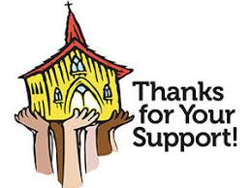
Continued Support for our Congregations
Please prayerfully consider how you can continue to support your congregation’s ongoing ministries during this time.
- Offerings can be mailed to the church address itself
- PAR forms (for pre-authorized debit) are available from your church treasurer
- You can send your offering by E-TRANSFER through your bank. next page.
Send e-transfers for Claremont United to: treasurercuc@outlook.com
Send e-transfers for Goodwood United to: goodwooductreasurer@gmail.com

Thank you for your continued support of our congregation’s ministry.

Find us online! Check out our websites!
Check out our church websites for new updates during this time, including Sunday devotions, and information about coping with stress during COVID-19.

www.claremontunitedchurch.com
www.goodwoodunitedchurch.com

Find us on Facebook!

https://www.facebook.com/goodwoodunited
https://www.facebook.com/claremontunited

