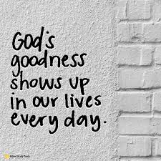
Welcome to Worship!
Sunday May 2, 2021, 10:30 am
5th Sunday of Easter
Claremont, Fairbank & Goodwood United Churches
Join us on Zoom or our YouTube channel: CFG Worship
Worship Leaders:
Rev. Lionel Ketola, and Pastor Steven Loweth
OneLicense # A-723979 CCLI # 11550809

Julian of Norwich Sermon Series: “Goodness, Joy & Awe”.

Words of Welcome

Introit: “Julian of Norwich” Linea Good Used with permisison

Lighting the Christ Candle
There was a man named Jesus, who brought healing and new life to all whom he met.
And he said “I am the light of the World”.

Acknowledgement of the Land
As we begin our worship, we acknowledge the history, spirituality and cultures of the First Nations who are the traditional custodians of the land where each of us is gathered today. Their relationship with the land remains central to their lives.
God of new life, ground us in love and justice so we can work toward reconciliation and fulfill our treaty obligations with Canada’s First Nations peoples. Amen.

Prayer of the Day
Loving Shepherd,
you know our names;
you care for us.
When we face darkness and death,
walk beside us.
When we hunger for your love,
fill us with your presence.
When we are fearful,
feed us at your table.
May we dwell in the house of goodness and mercy
all the days of our lives. Amen.

Opening Hymn: Come You Faithful, Raise the Strain VU 165 Used with Permission

We Gather Around God’s Word

One: Whether you take what is written in the Bible as fact, metaphor, myth or story, listen now to these words for the meaning they hold in your lives today.
All: May the Spirit bless us with wisdom and wonder, as we ponder the meaning of these words in our lives.

Responsive Psalm: Psalm 23 Chris Brunelle Used with permission

The Holy Gospel According to John (10:11-18)
¹¹“I am the good shepherd. The good shepherd lays down his life for the sheep. ¹²The hired hand, who is not the shepherd and does not own the sheep, sees the wolf coming and leaves the sheep and runs away—and the wolf snatches them and scatters them. ¹³The hired hand runs away because a hired hand does not care for the sheep. ¹⁴I am the good shepherd. I know my own and my own know me, ¹⁵just as the Father knows me and I know the Father. And I lay down my life for the sheep. ¹⁶I have other sheep that do not belong to this fold. I must bring them also, and they will listen to my voice. So there will be one flock, one shepherd. ¹⁷For this reason the Father loves me, because I lay down my life in order to take it up again. ¹⁸No one takes it from me, but I lay it down of my own accord. I have power to lay it down, and I have power to take it up again. I have received this command from my Father.”
Reflection: Pastor Steven Loweth “Goodness, Joy and Awe”

Hymn of the Day: VU 166 Joy Comes with the Dawn Alexandra Huynh Do

Affirming Moment Shirley Baster and Garth Spencer

Invitation to the Offering

Prayer of Dedication for the Gifts
Generous God,
through your Son, Jesus Christ,
you have shown us what it means to love.
And you call us to follow Your example—
to love our neighbours as we love ourselves.

Continue to write your law of love on our hearts.
Give us an unwavering passion for justice,
and a tenacious faith that will not rest
until the hungry are fed,
the oppressed find relief,
and the outsider finds a welcome. Amen.

Prayers of the People

Loving Shepherd,
you lead and guide,
you walk alongside,
you feed and embrace all of your sheep in unconditional love.
Strengthen your church throughout the world so we can bear witness to your expansive love. God in your love, hear our prayer.

We give thanks for the lush green pastures of our lives,
and for moments of joyful delight and surprise.
We pause now to offer our thanksgiving
for the goodness and joy that fills our lives … a silence is kept
God in your love, hear our prayer.

We pray for the nations of our world, and all who govern them.
We pray for all who are walking in the shadows of conflict, displacement and despair.
We pause now to name the broken places in our world …
God in your love, hear our prayer.

We pray for all who are struggling in valleys of fear and uncertainty, sickness and despair,
and for all who are struggling with illness, and with economic uncertainty during this time of pandemic. May we be your hearts and hands of compassion for our world.
God in your love, hear our prayer.

Tender Shepherd of us all, we lift up the needs of all who have asked for our prayers:

Intercessions are offered

Loving Shepherd, you restore us to wholeness and abundant life.
Into your hands we commend all for whom we pray, trusting in your
never-ending goodness and mercy, we pray with the words that Jesus taught us:
God our Mother and Father in Heaven, hallowed be thy name …

Closing Song: VU 288 Great is Thy Faithfulness Used with Permission

Blessing:
Let us go forth into the world
with our hearts open to the joyful abundance
of God’s good gifts for us all.

May the blessing of God,
The Maker, Lover and Guardian of us all
be with you now and always.
Amen.

Sung Dismissal: Go Now in Peace CFG Virtual Choir

Church Announcements …. Next page

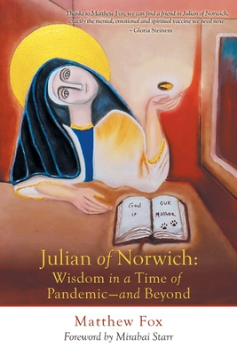
Julian of Norwich:
Wisdom in a time of Pandemic
A Sermon Series
based on the book by Matthew Fox

Rev. Lionel & Pastor Steve will be leading this 7 week Sermon Series based on Matthew Fox’s book. There will be a break mid-way when Rev Lionel and Pastor Steve are away on Study leave from May 16-23.
After the series is complete you may enjoy ordering the book to further reflect on it.

April 25 - Week 1 “Facing the Darkness”
Preacher: Rev. Lionel
Scriptures: Psalm 4, Luke 24: 36b-48

May 2 - Week 2 “Goodness, Joy & Awe”
Preacher: Pastor Steve
Scriptures: Psalm 23, John 10:11-18

May 9 – Week 3 “The Divine Feminine”
HOLY COMMUNION / Mother’s Day
Preacher: Rev. Lionel
Scriptures: Isaiah 66:13, Matthew 23: 37-39, Luke 15: 1-3, 8-10

(Rev. Lionel & Pastor Steve are off on Study Leave from Sun May 16 – Sun May 23 inclusive)

May 30 – Week 4 “God and Creation are One”
Preacher: Pastor Steve
Scriptures: Isaiah 6: 1-3, Psalm 19: 1, Psalm 26,

June 6 – Week 5 “Expanding our Vision: Beyond Dualism”
Preacher: Rev. Lionel
Scriptures: 1 Corinthians 1:10, Galatians 3:28, John 17: 1a, 11, 20-23

June 13 – Week 6 “Trusting our Sensuality”
Preacher: Pastor Steve
Scriptures: Psalm 139: 1-6 13-18, Genesis 1: 1-5, 26a, 27-31a.

June 20 – Week 7 “The Power of Love over Evil”
HOLY COMMUNION
Preaching: Rev. Lionel & Pastor Steve
Scriptures: Psalm 98, John 15:9-17

Goodwood United Church - Weekly Programs & Meetings

Tuesday May 4, 1:00 pm Worship Committee Meeting

The Knit-Wits: Wednesdays at 10:00 am. This is Goodwood United Church’s weekly ZOOM group for Knitting, crochet and other needle craft. This group facilitates our congregation’s Prayer Shawl Ministry. They will keep you in stitches! To find out how to connect with this group on Zoom, contact Shirley Baster.

Online Community Check-in: Thursdays at 10:30 AM, on Zoom. Join us for an opportunity to connect and find supportive community through our regular weekly check-in meetings. At the conclusion of our check-in time, we move into our weekly “Conversations about Life / Not your Typical Bible Study” group. Feel free to join us!

Book Study: Fridays at 10:00 am on Zoom – See Below for details of our Lent Study.

CLAREMONT UNITED CHURCH - Weekly Programs and Meetings

Wednesday May 5, at 7:30 pm – SESSION Meeting – Claremont United Church
Sorry about the incorrect date in last week’s bulletin. This is the correct date for our upcoming meeting the first week of May.

Wednesdays @ 12:00 noon – Join us for our weekly Zoom “drop-in” meeting. Everyone is invited to join us for these “Virtual Brock Café” Zoom gatherings to connect with our Claremont United Church community. Enjoy catching up with each other and sharing support.

Wed May 26, 7:30 pm - Official Board Meeting - Claremont United Church

Check out our new YouTube channel - CFG Worship
- Join us for worship either on Zoom, or on YouTube
- Watch past services uploaded to our YouTube channel
Go to Youtube.com and search CFG Worship.
And if you can, please click the subscribe button … Our goal is to get 100 subscribers, then we can get bonus stuff to boost our YouTube channel!
So please subscribe!

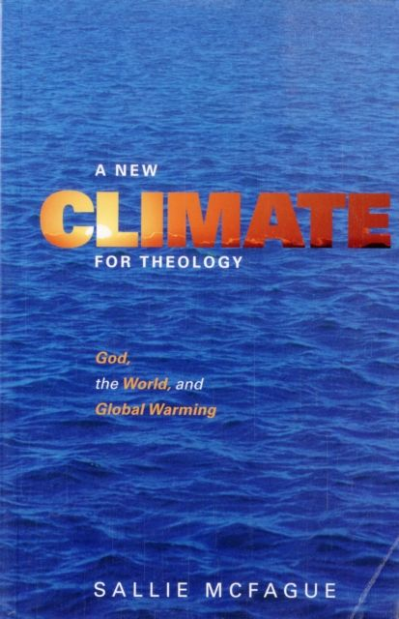
Join our BOOK STUDY GROUP
for all 3 Churches & friends:
Friday Mornings at 10:00 AM on Zoom.
For the next few weeks we are switching to a more informal format and gathering on Friday mornings for conversation about what we have read and also to share our thoughts about justice concerns and actions which we are interested in working on. We are (at our own pace) finishing up our reading of: UNSETTLING the WORD: Biblical Experiments in Decolonization.

On Friday May 28, we will begin our new book:
A New Climate for Theology:
God, the World, and Global Warming,
by Sallie McFague. It is an excellent book, so please join us!!
The book is available locally from Blue Heron in Uxbridge, if you don’t want to have to rely on the ‘big box’ online stores… so order yours now in time for May 28.

Continued Financial Support for our Congregations
Please prayerfully consider how you can continue to support
your congregation’s ongoing ministries during this time.
- Offerings can be mailed to the church address itself
- PAR forms (for pre-authorized debit) are available from your church treasurer
- You can send your offering by E-TRANSFER through your online banking. Here is where to send them:
For Claremont United send to: treasurercuc@outlook.com
For Goodwood United send to: goodwooductreasurer@gmail.com
Thank you for your continued support of our congregation’s ministry.

