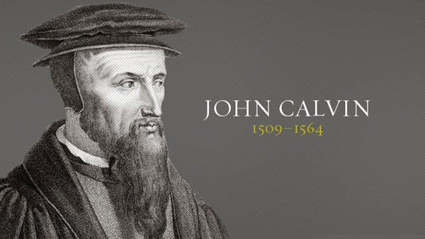
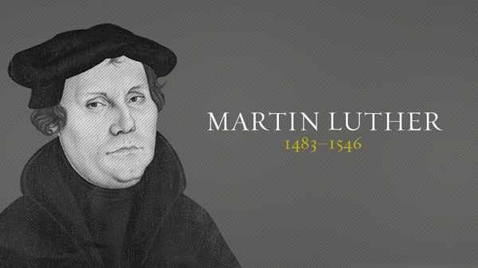

Sunday October 24th, 2021, REFORMATION SUNDAY
Service begins at: 10:30 am
23RD Sunday after Pentecost
A joint online worship Service with:
Claremont, Fairbank & Goodwood United Churches and Guests

Worship Leaders: Pastor Steven Loweth & Rev. Lionel Ketola
Onelicense # A-723979 CCLI # 11550809

Announcements & Today’s Worship Theme

We Joyfully Gather in God’s Presence

Introit: From Heaven Above, VU # 72, v. 1. Martin Luther The Masked Bandits

Lighting the Christ Candle
There was a man named Jesus, who embodied God’s love and compassion in such surprising ways. And he said: I am the light of the world

Acknowledgement of the Land
As we begin our worship, we acknowledge the history, spirituality and cultures of the First Nations who are the traditional custodians of the land where each of us is gathered today. Their relationship with the land remains central to their lives.
God of new life, ground us in love and justice so we can work toward reconciliation and fulfill our treaty obligations with the First Peoples of this land. Amen.

Call to Worship
God is our dwelling place from year to year, age to age.
And yet, we become complacent, forgetting who we are.
God reforms us
and makes prosperous the work of our hands!
God’s life surges forth through creation, like grass that renews every morning.
And yet we prefer to be dust, swept away in the wind of every new idea and new fad.
God reforms us
and makes prosperous the work of our hands!
God turns to us, and has compassion on us,
so the great work of our lives manifests Christ’s glorious love to the world.
God reforms us
and makes prosperous the work of our hands!

Prayer of the Day
Wondrous God:
Billions of years ago your creative spark called creation into being.
Two thousand years ago you lit a spark of new creation in Christ.
Five hundred years ago, your grace reignited the hearts of men and women
with names like Martin Luther, John Calvin, Katharina Zell, Ulrich Zwingli, and Argula von Grumbach.
Just when we think all is settled, everything is finished, closed,
your power and presence explodes on to the scene yet again, bringing newness, bringing life.
Fill us with your power and presence, O God,
so we may, like our grandparents in faith,
carry your truth, your beauty, and your justice to the world.
In Jesus’ name. Amen.

Opening Hymn: Love Divine All Loves Excelling VU 333 Charles Wesley
Music: The Masked Bandits & Julia Shatford

Invitation to Confession
An important outcome of the Protestant Reformation was the rediscovery of the doctrine of grace—the unmerited, unconditional love of God that reaches out to us even before we reach out to God. And as the great Reformer John Calvin once wrote,* the knowledge of God begins with knowledge of ourselves. To know ourselves is to know our places of brokenness. And to know God is to know that in Christ, God’s love stretches so deep and wide that it infiltrates every broken place in our hearts and in our world. God knows the depth of our hearts and will never turn away or turn us away. So let’s offer up our lives in confession, trusting that we can be honest before God and each other without fear. Let us pray.
* in The Institutes of the Christian Religion

Prayer of Confession
Living God,
You are the One who is always on the move,
always creating and re-creating,
always doing a new thing.
And yet, we confess, O Lord,
that our lives can become static,
routinely paralyzed by doubt and fear.
We remain ossified in patterns of greed,
covetousness, and self-interest.
We doubt your promises of abundant, everlasting life
and so we live in dread of our neighbours,
our friends, and our enemies.
Our souls remain still.
We do not love as you love.
Nor do we live as you would have us live,
with courage, generosity or the boldness of the gospel.
So in the silence of our hearts,
we offer up to you those things we have done and those we have left undone.
(short silence)
Forgive us, O God.
Renew us by your Spirit,
and reform us with your compassion,
remaking us more fully in to the image of Christ,
and as nimble servants of your reign.
Amen.

Assurance of Grace
Friends, the good news of the gospel
is that God’s love in Christ stretches so deep and so wide
that it infiltrates every broken place in our hearts
and in our world.
Our hatred is met with love,
our cruelty is met with compassion,
our sins and our trespasses are met with forgiveness.
It is greater than anything you have ever done,
or could do.
Open your hearts to let the love of God in,
because in Christ you are forgiven, freed, made new.
Believe in this great good news. Amen.

Hymn of Praise: God of the Bible MV 28 The Masked Bandits & Julia Shatford

We Open our Hearts to the Spirit’s Voice

One: Whether you take what is written in the Bible as fact, metaphor, myth or story, listen now to these words for the meaning they hold in your lives today.
All: May the Spirit bless us with wisdom and wonder, as we ponder the meaning of these words in our lives.

Ruth 1:1-18
1In the days when the judges ruled, there was a famine in the land, and a certain man of Bethlehem in Judah went to live in the country of Moab, he and his wife and two sons. ²The name of the man was Elimelech and the name of his wife Naomi, and the names of his two sons were Mahlon and Chilion; they were Ephrathites from Bethlehem in Judah. They went into the country of Moab and remained there. ³But Elimelech, the husband of Naomi, died, and she was left with her two sons. ⁴These took Moabite wives; the name of the one was Orpah and the name of the other Ruth. When they had lived there about ten years, ⁵both Mahlon and Chilion also died, so that the woman was left without her two sons and her husband.
⁶Then she started to return with her daughters-in-law from the country of Moab, for she had heard in the country of Moab that the Lord had considered his people and given them food. ⁷So she set out from the place where she had been living, she and her two daughters-in-law, and they went on their way to go back to the land of Judah. ⁸But Naomi said to her two daughters-in-law, “Go back each of you to your mother’s house. May the Lord deal kindly with you, as you have dealt with the dead and with me. ⁹The Lord grant that you may find security, each of you in the house of your husband.” Then she kissed them, and they wept aloud. ¹⁰They said to her, “No, we will return with you to your people.” ¹¹But Naomi said, “Turn back, my daughters, why will you go with me? Do I still have sons in my womb that they may become your husbands? ¹²Turn back, my daughters, go your way, for I am too old to have a husband. Even if I thought there was hope for me, even if I should have a husband tonight and bear sons, ¹³would you then wait until they were grown? Would you then refrain from marrying? No, my daughters, it has been far more bitter for me than for you, because the hand of the Lord has turned against me.” ¹⁴Then they wept aloud again. Orpah kissed her mother-in-law, but Ruth clung to her. ¹⁵So she said, “See, your sister-in-law has gone back to her people and to her gods; return after your sister-in-law.” ¹⁶But Ruth said, “Do not press me to leave you or to turn back from following you! Where you go, I will go; Where you lodge, I will lodge; your people shall be my people, and your God my God. ¹⁷Where you die, I will die— there will I be buried. May the Lord do thus and so to me, and more as well, if even death parts me from you!” ¹⁸When Naomi saw that she was determined to go with her, she said no more to her.
Holy Wisdom, Holy Word. Thanks be to God.

Reflection: Dr. Martin Luther (Nov 10, 1483 - Feb 18, 1546)

Hymn: A Mighty Fortress Is Our God VU 262 Martin Luther VIDEO

https://youtu.be/j-FHMLXzEIg

Responsive Psalm 146
¹Praise the Lord! Praise the Lord, O my soul!
²I will praise the Lord as long as I live; I will sing praises to my God all my life long.
³Do not put your trust in princes, in mortals, in whom there is no help.
⁴When their breath departs, they return to the earth; on that very day their plans perish.
⁵Happy are those whose help is the God of Jacob, whose hope is in the Lord their God,
⁶who made heaven and earth, the sea, and all that is in them; who keeps faith forever;
⁷who executes justice for the oppressed; who gives food to the hungry. The Lord sets the prisoners free;
⁸the Lord opens the eyes of the blind. The Lord lifts up those who are bowed down; the Lord loves the righteous.
⁹The Lord watches over the strangers; he upholds the orphan and the widow, but the way of the wicked he brings to ruin.
¹⁰The Lord will reign forever, your God, O Zion, for all generations. Praise the Lord!

Mark 12:28-34
²⁸One of the scribes came near and heard them disputing with one another, and seeing that he answered them well, he asked him, “Which commandment is the first of all?” ²⁹Jesus answered, “The first is, ‘Hear, O Israel: the Lord our God, the Lord is one; ³⁰you shall love the Lord your God with all your heart, and with all your soul, and with all your mind, and with all your strength.’ ³¹The second is this, ‘You shall love your neighbor as yourself.’ There is no other commandment greater than these.” ³²Then the scribe said to him, “You are right, Teacher; you have truly said that ‘he is one, and besides him there is no other’; ³³and ‘to love him with all the heart, and with all the understanding, and with all the strength,’ and ‘to love one’s neighbor as oneself,’ —this is much more important than all whole burnt offerings and sacrifices.” ³⁴When Jesus saw that he answered wisely, he said to him, “You are not far from the kingdom of God.” After that no one dared to ask him any question.
Holy Wisdom, Holy Word. Thanks be to God.

Reflection: John Calvin (July 10, 1509 – May 27, 1564)

Hymn: O For A Thousand Tongues To Sing VU 326 Charles Wesley

Prayers for the People
God of Grace and God of Glory,
On this Reformation Sunday, we give you thanks for the saints who have gone before us.
For those who faced trouble and trial, and even death,
for the sake of the message of your mercy and in the spirit of Pentecost, the right to hear and read the scriptures in their own languages.
We pray especially for those who now face trouble, trial, even death,
for those members of the body of Christ who face persecution.
For your beloved children everywhere—regardless of tradition—
who live under the threat of religious persecution.
For people, especially members of Indigenous communities, who face the extinction of our own languages through neglect, oppression, or cultural pressure.
We pray that all may hear the good news of the Prince of Peace in ways that resonate,
and cause us to drop our weapons and defences for the sake of the kingdom.
We pray that you may help us not only walk in the shoes of our forebears, but fill them.
May all of us gathered here today be as captivated by the life you have given us in Christ
that we are freed to reach our friends, neighbours, and enemies with your unconditional love.
Lord, we pray for the world you love
in hope, and in trust,
that we and your church might carry the light that has been passed down through the centuries,
so we might be a beacon of your love to the world.
Amen.

At this time, we remember all who have asked for our prayers:

Prayers of intercession are spoken

Confident in your great love for us, we entrust our prayers to you, O God, as we pray together: “God, our Mother and Father in Heaven, hallowed be thy name... Amen.”

Offertory Prayer
Loving God, you bless us with the gift of community – where our faith and hope are nurtured. Take the gifts which we offer this day - our talents and energies, our joys and passions – and use them to share your love. Take our challenges and regrets, our questions and struggles, and use them to bring healing to our world. We ask this through Christ, who makes us one in your love. Amen.

Closing Hymn: Go To the World VU 420 VIDEO
https://youtu.be/fmQDeSWdFrQ

Sending Forth
—words attributed to John Wesley
Go out into the world,
living in the light of Christ!
By the power of the Spirit
do all the good you can
by all the means you can
in all the ways you can
in all the places you can
at all the times you can
to all the people you can
as long as ever you can.
And may the grace of our Lord Jesus Christ,
the love of God,
and the communion of the Holy Spirit
be yours this day, and every other one.
Amen.

Church News and Announcements
See next page
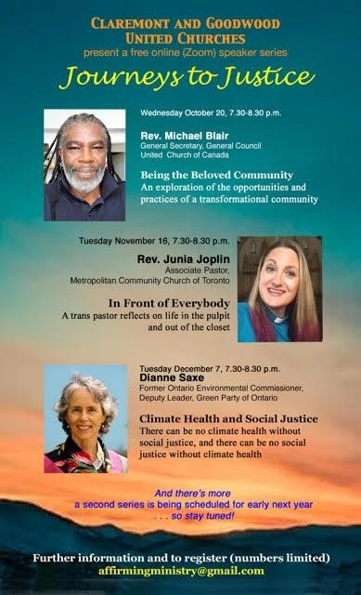
Goodwood United Church
-

Weekly Programs & Meetings

Goodwood United Church - Weekly Programs and Meetings

The Knit-Wits: Wednesdays at 10:00 am. This is Goodwood United Church’s weekly ZOOM group for Knitting, crochet and other needle craft. This group facilitates our congregation’s Prayer Shawl Ministry. They will keep you in stitches! To find out how to connect with this group on Zoom, contact Shirley Baster.

Thursday Mornings from 10-11 am - “Outdoor Coffee Gathering in the church parking lot” (Unless there is heavy rain that day). Join us outside the church (and bring your camping chair if you like) for a safe, socially distanced gathering for coffee & conversation outside of the church building. All COVID-19 precautions will be observed.

Book Study Group – Friday mornings at 10:00 am (see below for details)

Claremont United Church - Weekly Programs and Meetings

Wednesdays at 10:00 am – Join us for our Online Zoom Check in
Enjoy a chance to connect with our church community and share stories, laughter and support for this online gathering.

Wed November 3, 7:30 pm Claremont United Church Official Board Meeting
Join us for this important board meeting to discuss plans for re-opening.

Discernment Process – Please sign up to participate in a Wisdom Circle!
Earlier this year, our Claremont United Church’s Board has voted to begin a Discernment process which will use the “wisdom circle process” to discern what our future as a congregation could look like! This is a very exciting process to begin, as we seek the Spirit’s guidance about our future shape & ministries.

We are now ready to begin hosting Wisdom Circles. Please sign up to participate in this process by sending an email to Rev. Lionel at claremontunitedchurch@gmail.com.

Participants should expect to be involved in a monthly meeting for approx. 6 months’ time. You will remain in the same group for the duration of the process. Please indicate whether you would prefer to attend a daytime or evening meeting for your circle. Once we hear back from a good number of our members, we will announce the first meeting times. Looking forward to your involvement! Rev. Lionel
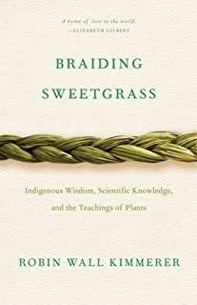
Join us for our Friday Morning Book Study,
Friday mornings at 10:00 am, on Zoom.
To get the Zoom link please contact Rev. Lionel.

Join us as we read: Braiding Sweetgrass: Indigenous Wisdom, Scientific Knowledge and the Teachings of Plants, by Robin Wall Kimmerer.

A word to newcomers: Don’t worry about joining us part way through – we are taking the book chapter by chapter with a slow reflective pace, and each chapter has its own unique theme. So there is no “right” time to join our study. So join us as we enjoy this very inspiring book!

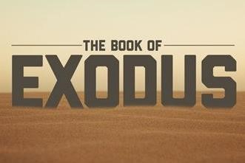

An Invitation to a Zoom Bible Study: The Book of Exodus, online, led by Rev. Kim at Mount Zion United Church

Rev. Kim Lawrence, serving at Greenwood-Mt. Zion United Church, has invited Goodwood and Claremont United members who are interested to join them for their Zoom Bible study – this is a 6-week Bible Study which is exploring the 2nd half of the Book of Exodus.

Time: Thursdays, 7-8 pm, on Zoom.
To join, email Rev. Kim Lawrence at: mountzionunitedchurch@gmail.com

Join us for Worship on our YouTube channel - CFG Worship
- Join us for worship either on Zoom, or on YouTube, Sundays at 10:30 am
- Watch past services uploaded to our YouTube channel Go to Youtube.com and search CFG Worship.

Continued Financial Support for our Congregations
Please prayerfully consider how you can continue to support your congregation’s ongoing ministries during this time.

Offerings can be mailed to the church address itself:
PAR forms (for pre-authorized debit) are available from your church treasurer
You can send your offering by E-TRANSFER through your online banking. Here is where to send them:

For Claremont United send to: treasurercuc@outlook.com For Goodwood United send to: goodwooductreasurer@gmail.com
Thank you for your continued support of our congregation’s ministry.

