Evening Prayer during lent
A Joint Worship Service for Claremont, Fairbank & Goodwood United Churches & friends.

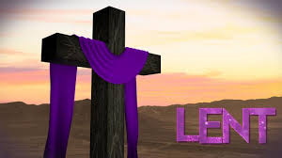

Opening Hymn: VU 438 The Day Thou Gavest Lord Has Ended Video

Greeting

One: Create in me a clean heart, O God, and renew a right spirit within me.
All: May the grace of Jesus Christ, the love of God,
and the communion of the Holy Spirit be with us all.

Sung Meditation: VU 411 O God We Call https://youtu.be/eLCR8xMQ_Os
O God we call, O God we call
from deep inside we yearn, from deep inside we yearn,
from deep inside we yearn for you. (repeat twice)
Prayer:
One: Let us pray:
All: Holy God, In love you created us and called our being good.
With open hearts, we praise you for your unfailing love.
With open hands, we offer you the labours of this day.
Let your blessing rest with us now, as the day turns toward evening.
Through your grace, may we share with others
the love you so freely give us. We ask this in Jesus’ name. Amen.

Song of Praise: Bless the Lord My soul 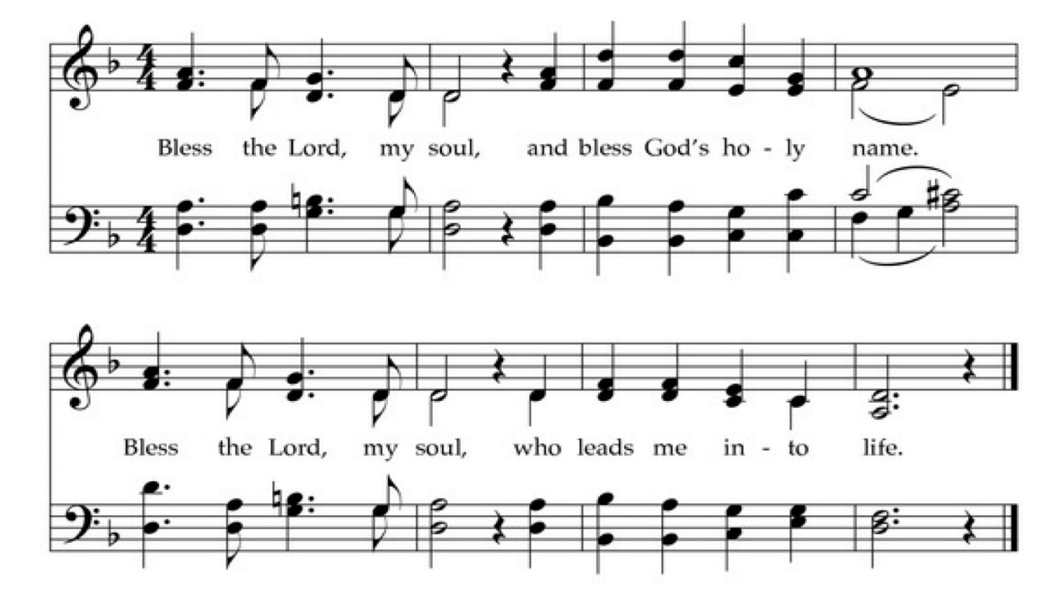

Scripture Reading: Psalm 130

1 Out of the depths I cry to you, YHWH!
2 God, hear my voice!
Let your ears be attentive
to my voice, my cries for mercy!
3 If you kept track of our sins, YHWH,
who could stand before you?
4 But with you is forgiveness,
and for this we revere you.
5 So I wait for you, YHWH—
my soul waits,
and in your word I place my trust.
6 My soul longs for you, YHWH,
more than sentinels long for the dawn,
more than sentinels long for the dawn.
7 Israel, put your hope in YHWH,
for with YHWH is abundant love
and the fullness of deliverance;
8 God will deliver Israel
from all its failings.

A Question for personal Reflection
During this season of lent
what has your soul been waiting for and longing for?

Silence for reflection

An Evening Psalm Psalm 131

O Lord, I am not proud;
I have no haughty looks.
I do not occupy myself
with great matters
or with things that are too hard for me.
But I still my soul and make it quiet,
like a child upon it’s mother’s breast;
my soul is quieted within me.
O Israel, wait upon the Lord,
from this time forth forevermore.

Psalm Prayer

God of earthquake, wind and fire,
may we also know your presence in the voice of silence.
Teach us the way of quiet,
that we may find peace in your presence;
Through Christ our Saviour. Amen.

Song: Nothing Can Trouble VU 290 (music on next page)

https://youtu.be/UuQXTTjx3U8

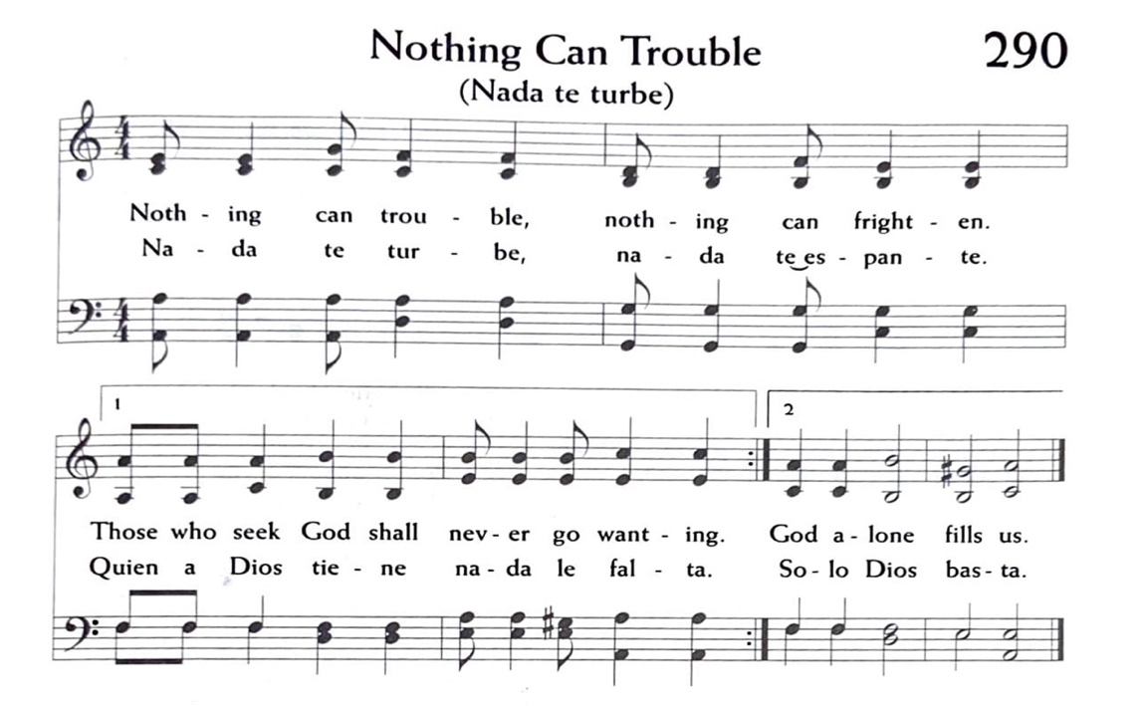
Scripture Sentences

You are in our mist, O God,
and you have named us as yours;
do not forsake us, O Lord our God. Jeremiah 14:9

Peace is my parting gift to you,
my own peace, such as the world cannot give.
Set your troubled hearts at rest,
and banish your fears. John 14:27

Prayer

Let us pray:

Be present with us this night, O God,
and grant that we who are wearied
by the changes and chances of life
may find our rest in you;
through Christ our Saviour. Amen.

Blessing

As the moon traces its light across the surface of the water,
As starlight pricks the blanket of night,
So may God’s love and light
Shine in your heart and in your dreaming.
May the blessing of God,
Creator, Christ and Holy Spirit
be with you now and always. Amen.

Closing Song: All Through the Night The Masked Bandits

