Welcome to Worship!
Sunday May 9, 2021, 10:30 am
6th Sunday of Easter
Holy Communion Service
Claremont, Fairbank & Goodwood United Churches
Join us on Zoom or our YouTube channel: CFG Worship
Worship Leaders: Rev. Lionel Ketola, and Pastor Steven Loweth
OneLicense # A-723979 CCLI # 11550809

Julian of Norwich Sermon Series:
“The Divine Feminine and the Motherhood of God”

Words of Welcome

Introit: “Julian of Norwich” Linnea Good

Lighting the Christ Candle
There was a man named Jesus, who brought healing and new life to all whom he met.
And he said “I am the light of the World”.

Acknowledgement of the Land
As we begin our worship, we acknowledge the history, spirituality and cultures of the First Nations who are the traditional custodians of the land where each of us is gathered today. Their relationship with the land remains central to their lives.
God of new life, ground us in love and justice so we can work toward reconciliation and fulfill our treaty obligations with Canada’s First Nations peoples. Amen.

Prayer of the Day
Mothering God, Source of love,
you reach out like a mother hen to gather us under your wings.
In your embrace we discover our identity as your beloved children.
Nourish and guide us in relationship with you
so we can grow into all of the fullness
of who you are calling us to be;
through Christ our Mother. Amen.

Opening Hymn: Children of the Heavenly Father

We Gather Around God’s Word

One: Whether you take what is written in the Bible as fact, metaphor, myth or story, listen now to these words for the meaning they hold in your lives today.
All: May the Spirit bless us with wisdom and wonder, as we ponder the meaning of these words in our lives.

Our first reading is from the Prophet Isaiah (66:13)

¹³As a mother comforts her child, so I will comfort you; you shall be comforted in Jerusalem.

Our Second Reading is from the Gospel of Matthew (23: 37-39)

³⁷“Jerusalem, Jerusalem … How often have I desired to gather your children together as a hen gathers her brood under her wings…

Our Third Reading is from the Gospel of Luke (15: 1-3, 8-10.)

Now all the tax collectors and sinners were coming near to listen to him. ²And the Pharisees and the scribes were grumbling and saying, “This fellow welcomes sinners and eats with them.” ³So Jesus told them this parable:

… What woman having ten silver coins, if she loses one of them, does not light a lamp, sweep the house, and search carefully until she finds it? ⁹When she has found it, she calls together her friends and neighbors, saying, ‘Rejoice with me, for I have found the coin that I had lost.’ ¹⁰Just so, I tell you, there is joy in the presence of the angels of God over one sinner who repents.”

Holy Wisdom, Holy Word
Thanks be to God!

Sermon: Rev. Lionel Ketola

Hymn of the Day: VU # 320 Mothering God You Gave Us Birth
Music with thanks to: Gabrielle Untermann, Jane Plewman, Julia Watts

Minute for Mission
Invitation to the Offering

Prayer of Dedication for the Gifts
Generous God,
through your Son, Jesus Christ,
you have shown us what it means to love.
Through the gifts we offer, may we follow your example
to love our neighbours as we love ourselves.

Continue to write your law of love on our hearts.
Give us an unwavering passion for justice,
and a tenacious faith that will not rest
until the hungry are fed,
the oppressed find relief,
and the outsider finds a welcome. Amen.

Prayers of the People Prayer of Intercession for Mothers

Good and loving God,
your love is the model for all parents,
and we thank you for the ways
in which our mothers showed us that love
in comforting our sadness, quelling our fears,
teaching us about the world and our place in it.

For young mothers,
learning to care for their children and their needs,
for experienced mothers,
learning to let go of their kids,
for mothers who are struggling to find the resources to
raise their families.

For women who have seen the wisdom of finding their babies another home,
and for foster mothers and adoptive mothers who have provided that home and protection.

For frontline mothers who are risking their safety at work during this time of pandemic.

God in Your love, Hear our Prayer

Tender God, we lift up the needs of all who have asked for our prayers:

Intercessions are offered

Into your hands we commend all for whom we pray, trusting in your love and care for us all;
Through our Christ our saviour. Amen.

Holy Communion

May God be with you

And also with you

Lift up your hearts

We lift them up to God

Let us give thanks to our Creator

It is right to give our thanks and praise.

Blessed are you Mothering God,
You birthed us from the rich soils of the earth.
You have made us part of an intricate and awe-filled web of life.

We experience your tender love and self-giving in so many ways:
In the beauty of creation
Through the life and ministry of Jesus
Through your Spirit’s guiding and empowering presence.

Blessed is Jesus, child of Mary,
who on the night that he was betrayed Jesus took bread,
gave thanks, broke it, and gave it to his disciples saying:

Take and eat, for this is my body given for you. Do this in remembrance of me.
This bread will nourish you to be partners with God in the new kingdom that
God is bringing to birth in our world.

And then Jesus took the cup and blessed it and said:
Take and drink, this is the cup of the new covenant relationship with God.
Do this in remembrance of me. This cup will nourish you to be partners with
God in the new kingdom that God is bringing to birth in our world.

Loving God, like a mother, you brought all things into being.
Through trial and truth-telling, touch, and tenderness,
you nurture your people and lead us in the way of justice and peace.
Send your Holy Spirit upon us and upon this bread and this cup,
that they may be for us the body and blood of Christ.
Feed us with these gifts so that we can be the living and loving body of Christ in our world.

With Christ our Mother we pray: God our Mother and Father in Heaven…

At the breaking of the bread

The gifts of God for the people of God
Thanks be to God

Prayer after Communion
Mothering God,
You feed us with your life-giving bread at your table of grace.
Send us into the world with hearts filled with peace.
Grant us the strength and courage
to be your servant people.
In Christ’s name we pray, Amen.

Closing Song: Will You Bless Our Homes and Families Gabrielle, Jane & Julia

Blessing:
May God, who gave birth to all creation, love us;
May God, who became incarnate by an earthly mother, teach us;
May God, who broods as a mother over her children, protect us;
And may the blessing of God, Creator, Christ and Holy Spirit,
be with us now and forever.
Amen.

Sung Dismissal: All You Need is Love Used with Permission
With thanks to Rev. Tyler Gingrich, Gloria Dei Lutheran Church, Winnipeg

Church Announcements

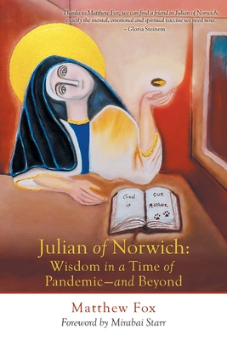
Julian of Norwich:
Wisdom in a time of Pandemic
A Sermon Series
based on the book by Matthew Fox

Rev. Lionel & Pastor Steve will be leading this 7 week Sermon Series based on Matthew Fox’s book. There will be a break mid-way when Rev Lionel and Pastor Steve are away on Study leave from May 16-23.
After the series is complete you may enjoy ordering the book to further reflect on it.

April 25 - Week 1 “Facing the Darkness”
Preacher: Rev. Lionel
Scriptures: Psalm 4, Luke 24: 36b-48

May 2 - Week 2 “Goodness, Joy & Awe”
Preacher: Pastor Steve
Scriptures: Psalm 23, John 10:11-18

May 9 – Week 3 “The Divine Feminine”
HOLY COMMUNION / Mother’s Day
Preacher: Rev. Lionel
Scriptures: Isaiah 66:13, Matthew 23: 37-39, Luke 15: 1-3, 8-10

(Rev. Lionel & Pastor Steve are off on Study Leave from Sun May 16 – Sun May 23 inclusive)

May 30 – Week 4 “God and Creation are One”
Preacher: Pastor Steve
Scriptures: Isaiah 6: 1-3, Psalm 19: 1, Psalm 26,

June 6 – Week 5 “Expanding our Vision: Beyond Dualism”
Preacher: Rev. Lionel
Scriptures: 1 Corinthians 1:10, Galatians 3:28, John 17: 1a, 11, 20-23

June 13 – Week 6 “Trusting our Sensuality”
Preacher: Pastor Steve
Scriptures: Psalm 139: 1-6 13-18, Genesis 1: 1-5, 26a, 27-31a.

June 20 – Week 7 “The Power of Love over Evil”
HOLY COMMUNION
Preaching: Rev. Lionel & Pastor Steve
Scriptures: Psalm 98, John 15:9-17

Goodwood United Church - Weekly Programs & Meetings

Goodwood United Church BOARD MEETING - Wednesday May 12, 7:00 pm

The Knit-Wits: Wednesdays at 10:00 am. This is Goodwood United Church’s weekly ZOOM group for Knitting, crochet and other needle craft. This group facilitates our congregation’s Prayer Shawl Ministry. They will keep you in stitches! To find out how to connect with this group on Zoom, contact Shirley Baster.

Online Community Check-in: Thursdays at 10:30 AM, on Zoom. Join us for an opportunity to connect and find supportive community through our regular weekly check-in meetings. At the conclusion of our check-in time, we move into our weekly “Conversations about Life / Not your Typical Bible Study” group. Feel free to join us!

Book Study: Fridays at 10:00 am on Zoom – See Below for details of our Lent Study.

Claremont United Church - Weekly Programs and Meetings

Wednesdays @ 12:00 noon – Join us for our weekly Zoom “drop-in” meeting. Everyone is invited to join us for these “Virtual Brock Café” Zoom gatherings to connect with our Claremont United Church community. Enjoy catching up with each other and sharing support.

Wed May 26, 7:30 pm - Official Board Meeting - Claremont United Church

Check out our new YouTube channel - CFG Worship
- Join us for worship either on Zoom, or on YouTube
- Watch past services uploaded to our YouTube channel
Go to Youtube.com and search CFG Worship.
And if you can, please click the subscribe button … Our goal is to get 100 subscribers, then we can get bonus stuff to boost our YouTube channel!
So please subscribe!

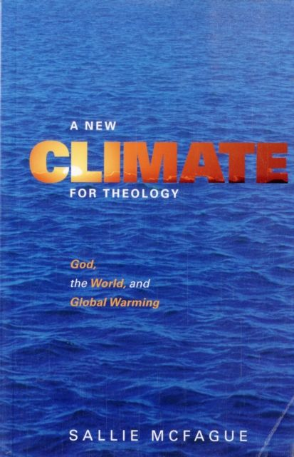
Join our BOOK STUDY GROUP
for all 3 Churches & friends:
Friday Mornings at 10:00 AM on Zoom.
For the next few weeks we are switching to a more informal format and gathering on Friday mornings for conversation about what we have read and also to share our thoughts about justice concerns and actions which we are interested in working on. We are (at our own pace) finishing up our reading of: UNSETTLING the WORD: Biblical Experiments in Decolonization.

On Friday June 4th we will begin our new book:
A New Climate for Theology:
God, the World, and Global Warming,
by Sallie McFague. It is an excellent book, so please join us!!
The book is available locally from Blue Heron in Uxbridge, if you don’t want to have to rely on the ‘big box’ online stores… so order yours now in time for May 28.

Continued Financial Support for our Congregations
Please prayerfully consider how you can continue to support
your congregation’s ongoing ministries during this time.
- Offerings can be mailed to the church address itself
- PAR forms (for pre-authorized debit) are available from your church treasurer
- You can send your offering by E-TRANSFER through your online banking. Here is where to send them:
For Claremont United send to: treasurercuc@outlook.com
For Goodwood United send to: goodwooductreasurer@gmail.com
Thank you for your continued support of our congregation’s ministry.

