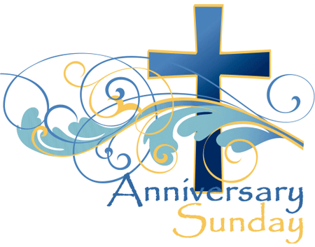
Welcome to worship!
Sunday October 24th, 2021
ANNIVERSARY SUNDAY
22ND Sunday after Pentecost
A joint online Zoom worship Service with:
Claremont, Fairbank & Goodwood United
Churches and Guests

Worship Leaders: Pastor Steven Loweth & Rev. Lionel Ketola
Onelicense # A-723979 CCLI # 11550809

Announcements & Today’s Worship Theme

We Joyfully Gather in God’s Presence

Introit: Spirit, Open my Heart MV # 79, v. 2 Alexandra Huynh Do

Lighting the Christ Candle
There was a man named Jesus, who embodied God’s love and compassion in such surprising ways. And he said: I am the light of the world

Acknowledgement of the Land
As we begin our worship, we acknowledge the history, spirituality and cultures of the First Nations who are the traditional custodians of the land where each of us is gathered today. Their relationship with the land remains central to their lives.
God of new life, ground us in love and justice so we can work toward reconciliation and fulfill our treaty obligations with the First Peoples of this land. Amen.

Call to Worship

When I think of God’s presence in the world, I am grateful:
Grateful for the presence of hope; grateful for the gift of life.
And when I think of God’s presence in my life, I am humbled:
Humbled by the gift of grace; humbled by the invitation to begin again.
And when I think of God’s presence in this community, I am glad:
Glad to be surrounded by God’s people as we worship and give thanks this day!

Opening Hymn: We are One as we Come VU 402

Prayer of the Day
Loving and Gracious God,
we come into your presence with joyful hearts,
asking for the blessing of your presence on this day of celebration.

We give thanks for the congregations of Claremont, Fairbank and Goodwood United Churches – communities of faith where we have been
claimed by your living waters in our baptism,
fed at your table of grace
enlivened by relationships in community,
comforted through the storms of our lives,
uplifted in moments of joyful celebration
and united by working together in mission to share love and justice in our world.

Fill our hearts with the assurance that you continue to walk with us into our futures.
Ground us in your deep and unfailing love for us
so we can continue to be and share the Christ-light for our world.
We ask this in the name of Jesus, the rock on which our communities find their sure foundation. Amen.

We Open our Hearts to the Spirit’s Voice

One: Whether you take what is written in the Bible as fact, metaphor, myth or story, listen now to these words for the meaning they hold in your lives today.
All: May the Spirit bless us with wisdom and wonder, as we ponder the meaning of these words in our lives.

Psalm 104: 1-6, 10-17

¹ Bless the Lord, O my soul.
O Lord my God, you are very great.
You are clothed with honor and majesty,
² wrapped in light as with a garment.
You stretch out the heavens like a tent,
³ you set the beams of your^{[a]} chambers on the waters,
you make the clouds your^{[b]} chariot,
you ride on the wings of the wind,
⁴ you make the winds your^{[c]} messengers,
fire and flame your^{[d]} ministers.
⁵ You set the earth on its foundations,
so that it shall never be shaken.
⁶ You cover it with the deep as with a garment;
the waters stood above the mountains.
¹⁰ You make springs gush forth in the valleys;
they flow between the hills,
¹¹ giving drink to every wild animal;
the wild asses quench their thirst.
¹² By the streams^{[e]} the birds of the air have their habitation;
they sing among the branches.
¹³ From your lofty abode you water the mountains;
the earth is satisfied with the fruit of your work.
¹⁴ You cause the grass to grow for the cattle,
and plants for people to use,^{[f]}
to bring forth food from the earth,
¹⁵ and wine to gladden the human heart,
oil to make the face shine,
and bread to strengthen the human heart.
¹⁶ The trees of the Lord are watered abundantly,
the cedars of Lebanon that he planted.
¹⁷ In them the birds build their nests;
the stork has its home in the fir trees.
Holy Wisdom, Holy Word. Thanks be to God.

Brief Reflection: Pastor Steven Loweth

Mark 10:46-52
⁴⁶They came to Jericho. As he and his disciples and a large crowd were leaving Jericho, Bartimaeus son of Timaeus, a blind beggar, was sitting by the roadside. ⁴⁷When he heard that it was Jesus of Nazareth, he began to shout out and say, “Jesus, Son of David, have mercy on me!” ⁴⁸Many sternly ordered him to be quiet, but he cried out even more loudly, “Son of David, have mercy on me!” ⁴⁹Jesus stood still and said, “Call him here.” And they called the blind man, saying to him, “Take heart; get up, he is calling you.” ⁵⁰So throwing off his cloak, he sprang up and came to Jesus. ⁵¹Then Jesus said to him, “What do you want me to do for you?” The blind man said to him, “My teacher, let me see again.” ⁵²Jesus said to him, “Go; your faith has made you well.” Immediately he regained his sight and followed him on the way.
Holy Wisdom, Holy Word. Thanks be to God.

Brief Reflection – Rev. Lionel

Sermon Hymn: O Master Let me walk with Thee VU 560

Anniversary Video - Claremont United Church
Song: Blest Be the Tie VU 602 verse 1 Masked Bandits & Julia Shatford

Anniversary Video - Fairbank United Church
Song: Blest Be the Tie VU 602 v. 2

Anniversary Video – Goodwood United Church
Song: Blest Be the Tie VU 602 v. 3-4

Prayers for the People
Holy One, you have brought us to this day of celebration,
and so we offer with gratitude our prayer of thanksgiving:

Hallelujah!
Praise God with street rap.
Praise God with Bach cantatas.
Praise God with tattooed hands.
Praise God with arthritic hands.
Praise God with smiling eyes.
Praise God with stuffy noses and pockets filled with hankies.
Praise God in stained glass sanctuaries
Praise God in pubs and dance halls.
Praise God in holy solitude
Praise God in the warmth of community.

Let every living, breathing,
big and tall, short and small,
beloved creature
praise God!
Hallelujah!
God in your love, hear our prayer.

At this time, we remember all who have asked for our prayers:

Prayers of intercession are spoken

Into your hands, O God, we commend all for whom we pray, through Christ our Saviour. Amen.

Invitation to the Offering

Video: A Special Thank you to Marean Ward, UCW chair, Claremont United Church

Offertory Prayer
Loving God, you bless us with the gift of community – where our faith and hope are nurtured. Take the gifts which we offer this day - our talents and energies, our joys and passions – and use them to share your love. Take our challenges and regrets, our questions and struggles, and use them to bring healing to our world. We ask this through Christ, who makes us one in your love. Amen.

Holy Communion
Friends, at this time we will set our communion table. We invite you to do the same in your homes. And as we do so, we give thanks for the tables that have been set in our congregations for many years – tables where we have found friendship, community, and Christ’s presence. All are welcome at Christ’s table as we celebrate today.
We will sing our communion hymn as we set our tables.

Communion Hymn: As We Gather at Your Table VU 457

May God be with you
And also with you
Lift up your hearts.
We lift them to the God.
Let us give thanks to the Lord our God.
It is right to give our thanks and praise.

We give you thanks, O God, for calling us to an adventure of faith.
You made us in your image to respond to your grace;
your story came alive
through the children of Israel,
and a promise was born
that one day
no face would be forgotten,
no body enslaved,
no spirit broken,
but all would join in the covenant of life.

You sent your Son in solidarity with us
healing our sickness
and confronting our demons;
he bore the cross and rose again
to disclose our true humanity.

On the night that Jesus was betrayed he shared a meal with his friend.
Jesus took bread …

We praise you for your journeying presence – beside us through the years.
We praise you for your journeying presence – leading us into our future.
Therefore we proclaim the mystery of our faith:
Christ has died
Christ is risen
Christ will come again.

Pour out your Spirit on these gifts of bread and cup,
and upon the congregations of Claremont, Fairbank and Goodwood United Churches.
Unite us in love, and empower us to work together
for the healing of the earth, and all creation.

With Christ our Saviour, we pray together:
“God our Mother and Father in heaven…”

At the Breaking of the Bread:
We break this bread to share in the one body.
We being many, are one body, for we all share in the one bread.
- We share the bread and the cup -

Prayer after Communion
Glory to God, whose power working in us
can do infinitely more than we can ask or image.
Glory to God from generation to generation,
in the Church and in Christ Jesus, for ever and ever. Amen

*Closing Hymn VU 509 I, the Lord of Sea and Sky VIDEO

Sending Forth

May we go forth filled with joy,
for God’s steadfast presence.

May we go forth filled with gratitude
for the inheritance of faith
that has been passed on to us
from many generations.

May we go forth filled with hope,
as we continue walking the road of love and service for our world.

May the blessing of God,
Creator, Christ and Holy Spirit
be with us and remain with us now and always. Amen.

Church News and Announcements
See next page
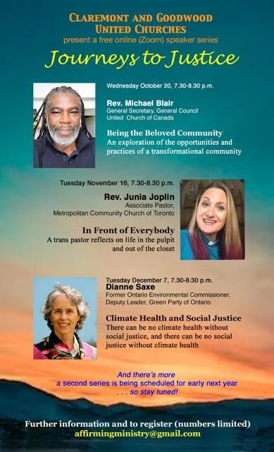
Goodwood United Church
-

Weekly Programs & Meetings

Goodwood United Church - Weekly Programs and Meetings

The Knit-Wits: Wednesdays at 10:00 am. This is Goodwood United Church’s weekly ZOOM group for Knitting, crochet and other needle craft. This group facilitates our congregation’s Prayer Shawl Ministry. They will keep you in stitches! To find out how to connect with this group on Zoom, contact Shirley Baster.

Thursday Mornings from 10-11 am - “Outdoor Coffee Gathering in the church parking lot” (Unless there is heavy rain that day). Join us outside the church (and bring your camping chair if you like) for a safe, socially distanced gathering for coffee & conversation outside of the church building. All COVID-19 precautions will be observed.

Wed Oct 27, 7:00 pm Joint Church Re-opening Committee (on zoom)

Book Study Group – Friday mornings at 10:00 am

Claremont United Church - Weekly Programs and Meetings

Wednesdays at 10:00 am – Join us for our Online Zoom Check in
Enjoy a chance to connect with our church community and share stories, laughter and support for this online gathering.

Tues Oct 26, 7:00 – 8:30 pm Circle Facilitator Training, Discernment Process

Wed Oct 27, 7:00 pm Joint Church Re-opening Committee (on zoom)

Book Study Group – Friday mornings at 10:00 am
Please read the second chapter (pages 11-21) for this week’s meeting.

DISCERNMENT PROCESS – CLAREMONT UNITED CHURCH’S FUTURE
Claremont United Church’s Board has voted to begin a Discernment process which will use the “wisdom circle process” to discern what our future as a congregation could look like! This is a very exciting process to begin, as we seek the Spirit’s guidance about our future shape & ministries. This process will be beginning soon … so stay tuned!
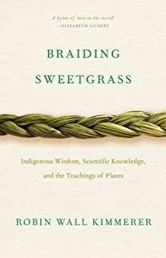
Join us for our Friday Morning Book Study,
Friday mornings at 10:00 am, on Zoom.
To get the Zoom link please contact Rev. Lionel.

Join us as we read: Braiding Sweetgrass: Indigenous Wisdom, Scientific Knowledge and the Teachings of Plants, by Robin Wall Kimmerer.

A word to newcomers: Don’t worry about joining us part way through – we are taking the book chapter by chapter with a slow reflective pace, and each chapter has its own unique theme. So there is no “right” time to join our study. So join us as we enjoy this very inspiring book!

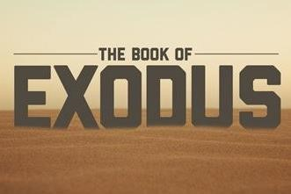

An Invitation to a Zoom Bible Study: The Book of Exodus, online, led by Rev. Kim at Mount Zion United Church

Rev. Kim Lawrence, serving at Greenwood-Mt. Zion United Church, has invited Goodwood and Claremont United members who are interested to join them for their Zoom Bible study – this is a 6-week Bible Study which is exploring the 2nd half of the Book of Exodus.

Time: Thursdays, 7-8 pm, on Zoom.
To join, email Rev. Kim Lawrence at: mountzionunitedchurch@gmail.com

Join us for Worship on our YouTube channel - CFG Worship
- Join us for worship either on Zoom, or on YouTube, Sundays at 10:30 am
- Watch past services uploaded to our YouTube channel Go to Youtube.com and search CFG Worship.

Continued Financial Support for our Congregations
Please prayerfully consider how you can continue to support your congregation’s ongoing ministries during this time.

Offerings can be mailed to the church address itself:
PAR forms (for pre-authorized debit) are available from your church treasurer
You can send your offering by E-TRANSFER through your online banking. Here is where to send them:

For Claremont United send to: treasurercuc@outlook.com For Goodwood United send to: goodwooductreasurer@gmail.com
Thank you for your continued support of our congregation’s ministry.

