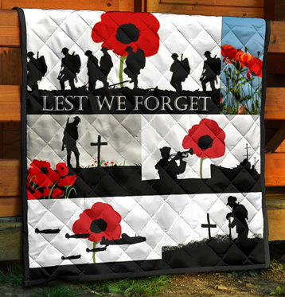
Welcome to worship!

Sunday November 7th, 2021

24th Sunday after Pentecost

Remembrance Sunday

A joint online Zoom worship Service with:

Claremont, Fairbank & Goodwood United Churches and Guests

Worship Leaders: Pastor Steven Loweth & Rev. Lionel Ketola
Onelicense # A-723979 CCLI # 11550809

We Joyfully Gather in God’s Presence

Lighting the Christ Candle
There was a man named Jesus, who embodied God’s love and compassion in such surprising ways. And he said: I am the light of the world

Acknowledgement of the Land
As we begin our worship, we acknowledge the history, spirituality and cultures of the First Nations who are the traditional custodians of the land where each of us is gathered today. Their relationship with the land remains central to their lives.
God of new life, ground us in love and justice so we can work toward reconciliation and fulfill our treaty obligations with the First Peoples of this land. Amen.

Call to Worship
As we gather for worship this Remembrance Sunday, hear the words of the Prophet Isaiah:
“God will judge between the nations
and will settle conflicts between many people.
They will beat their weapons of war into tools for peace.
Nation will no longer fight nation,
nor will they prepare for war anymore.”
Guided by this vision …
We lift our hearts in worship to the Source of Peace.

Prayer of the Day
God of peace, as the guns fell silent on November 11th so many years ago, it allowed your people to hear the sounds of hope and promise. And in that silence may we hear your still, small voice, calling us to a new vision of peace, justice, and reconciliation for our world.
We pray in Jesus’ name. Amen.

Opening Hymn: Introit: MV 221 I am Wallking a Path of Peace

Prayer of Confession
We live in a world of immense beauty and wonder …
And a world scarred by violence, alienation and war.
Healing God, we offer you our broken hearts, broken dreams,
and our hopes for a world made new. A Silence is kept

Sung Confession: (VU # VU 678 v, 1 & 2)
1 For the healing of the nations,
God, we pray with one accord;
for a just and equal sharing
of the things that earth affords.
To a life of love in action
help us rise and pledge our word.
2 Lead us forward into freedom,
from despair your world release;
that, redeemed from war and hatred,
all may come and go in peace.
Show us how through care and goodness
fear will die and hope increase.
Assurance of Forgiveness
Hear the good news that the Scriptures proclaim -
that no sheep is unworthy of rescue,
that no coin is too small to be missed.
Hear the good news
that love is stronger than hate
and that this power is alive within you, in Christ Jesus,
now and forever.
May your life be shaped anew by that good news! Amen.

We Open our Hearts to the Spirit’s Voice

One: Whether you take what is written in the Bible as fact, metaphor, myth or story, listen now to these words for the meaning they hold in your lives today.
All: May the Spirit bless us with wisdom and wonder, as we ponder the meaning of these words in our lives.

A Reading from the Prophet Isaiah 11:1-10
A shoot shall come out from the stump of Jesse, and a branch shall grow out of his roots. ²The spirit of the Lord shall rest on him, the spirit of wisdom and understanding, the spirit of counsel and might, the spirit of knowledge and the fear of the Lord. ³His delight shall be in the fear of the Lord. He shall not judge by what his eyes see, or decide by what his ears hear; ⁴but with righteousness he shall judge the poor, and decide with equity for the meek of the earth; he shall strike the earth with the rod of his mouth, and with the breath of his lips he shall kill the wicked. ⁵Righteousness shall be the belt around his waist, and faithfulness the belt around his loins. ⁶The wolf shall live with the lamb, the leopard shall lie down with the kid, the calf and the lion and the fatling together, and a little child shall lead them. ⁷The cow and the bear shall graze, their young shall lie down together; and the lion shall eat straw like the ox. ⁸The nursing child shall play over the hole of the asp, and the weaned child shall put its hand on the adder’s den. ⁹They will not hurt or destroy on all my holy mountain; for the earth will be full of the knowledge of the Lord as the waters cover the sea.
Holy Wisdom, Holy Word Thanks be to God.

VIDEO – In Flanders Field

Psalm Hymn VU page 806 O God our Help in Ages Past

The Holy Gospel according to Mark 13:1-8
As he came out of the temple, one of his disciples said to him, “Look, Teacher, what large stones and what large buildings!” ²Then Jesus asked him, “Do you see these great buildings? Not one stone will be left here upon another; all will be thrown down.”
³When he was sitting on the Mount of Olives opposite the temple, Peter, James, John, and Andrew asked him privately, ⁴“Tell us, when will this be, and what will be the sign that all these things are about to be accomplished?” ⁵Then Jesus began to say to them, “Beware that no one leads you astray. ⁶Many will come in my name and say, ‘I am he!’ and they will lead many astray. ⁷When you hear of wars and rumors of wars, do not be alarmed; this must take place, but the end is still to come. ⁸For nation will rise against nation, and kingdom against kingdom; there will be earthquakes in various places; there will be famines. This is but the beginning of the birthpangs.
Holy Wisdom, Holy Word Thanks be to God.

Sermon: Rev. Lionel

We Joyfully Respond to the Good News

Hymn of the Day: VU 684 Make Me a Channel of your Peace

An Affirmation of Hope:
(Scratched on a prison cell wall in Cologne, during World War 2)
I believe in the sun …
even when it does not shine.
I believe in love …
even when I cannot feel it.
I believe in God …
even when God is silent.

Invitation to the Offering

Prayer of Dedication for the Gifts
Risk-taking God, we give thanks for the courage of all who have given their very lives to the work of creating love, peace and freedom in our world.
Receive the offering of our lives, our time, our talent, and our resources.
Use what we offer, O God, to bring hope to our fragmented world.
We ask this in Jesus’ name. Amen.

Prayers of the People

God, we pray for the power to be gentle,
the strength to be forgiving,
the patience to be understanding,
and the courage to accept the consequences
of standing up for what we believe is just and right.

May we put our trust in the power of good to overcome evil
and the power of love to overcome hatred.
We pray for the vision to see and the faith to believe
in a world freed from domination and violence.

Help us to devote our whole life, thought and energy
to the task of making peace,
praying always for the inspiration and the power
to fulfill the destiny for which we were created.
God in your love, hear our prayer.

We give thanks for leaders who are working for peace for all nations, guiding the way towards a world where justice prevails. We pray for all who suffer the wounds of war: veterans who carry battle scars from the past; displaced people who carry the trauma of multiple losses as a result of war; and all who are grieving the loss of loved ones as a result of conflict.
Empower us to make your reign of love and peace a reality.
God in your love, hear our prayer.

We pray for the 28 countries across the globe which are either at war or are experieincig armed conflicts within their borders. Empower us to act and advocate for peace as individuals, as a church and as a nation.
God in your love, hear our prayer.

At this time, we remember all who have asked for our prayers…

Intercessions are offered

Into your hands, O God, we commend all for whom we pray, trusting in your great love, through Jesus, who taught us to pray: “God our Mother and Father in heaven….”

Closing Hymn: VU # 679 Let There be Light

Blessing

May we go forth into the world's turbulence
as instruments of God’s peace,
and as ambassadors of God’s loving justice,
so that all might know God’s healing and reconciling love.

And may the blessing of God,
Creator, Christ and Holy Spirit
be with you now and always! Amen.

Sung Blessing: Where Have All the Flowers Gone VIDEO

Church News and Announcements
See next page
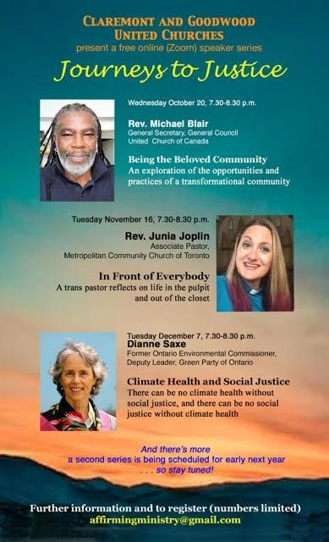
Goodwood United Church
-

Weekly Programs & Meetings

Goodwood United Church - Weekly Programs and Meetings

The Knit-Wits: Wednesdays at 10:00 am. This is Goodwood United Church’s weekly ZOOM group for Knitting, crochet and other needle craft. This group facilitates our congregation’s Prayer Shawl Ministry. They will keep you in stitches! To find out how to connect with this group on Zoom, contact Shirley Baster.

Thursday Check-in gathering at the Church: This week at 12:00 noon.
Join us and bring a coffee and a sandwich at noon for an hour of lunch and conversation.
At 1:00 pm we will have our Board meeting.
All COVID-19 precautions will be observed. Please self-screen before coming to the church.

Goodwood United Church Board: Thursday November 18, 1:00 pm at the church. COVID precautions will be observed. Bring your lunch at noon, for a social time, and at 1:00 pm our Board meeting will take place in the church. If you are not comfortable attending in person, a Zoom link will be sent out to attend online.

Book Study Group – Friday mornings at 10:00 am (see below for details)

Claremont United Church - Weekly Programs and Meetings

Wednesdays at 10:00 am – Join us for our Online Zoom Check in
Enjoy a chance to connect with our church community and share stories, laughter and support for this online gathering.

Tuesday Nov 16, 7:30 pm – Join us for our next Speaker Series event, with Rev Junia Joplin. See poster on next page to register (send an email to the email address at the bottom of the poster).

Wed Nov 17, 3:00 pm Affirming, Mission & Outreach Committee meeting – online, on ZOOM

Thursday Nov 17, 7:30 pm – Session Meeting – online on Zoom

Discernment Process – Please sign up to participate in a Wisdom Circle!
Earlier this year, our Claremont United Church’s Board has voted to begin a Discernment process which will use the “wisdom circle process” to discern what our future as a congregation could look like! This is a very exciting process to begin, as we seek the Spirit’s guidance about our future shape & ministries. We are now ready to begin hosting Wisdom Circles. Please sign up to participate in this process by sending an email to Rev. Lionel at claremontunitedchurch@gmail.com.
Participants should expect to be involved in a monthly meeting for approx. 6 months’ time. You will remain in the same group for the duration of the process. Please indicate whether you would prefer to attend a daytime or evening meeting for your circle. Once we hear back from a good number of our members, we will announce the first meeting times. Looking forward to your involvement! Rev. Lionel
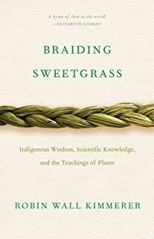
Join us for our
Friday Morning Book Study
Friday mornings at 10:00 am, on Zoom.
To get the Zoom link please contact Rev. Lionel.

Join us as we read: Braiding Sweetgrass: Indigenous Wisdom, Scientific Knowledge and the Teachings of Plants, by Robin Wall Kimmerer.

A word to newcomers: Don’t worry about joining us part way through – we are taking the book chapter by chapter with a slow reflective pace, and each chapter has its own unique theme. So there is no “right” time to join our study. So join us as we enjoy this very inspiring book!

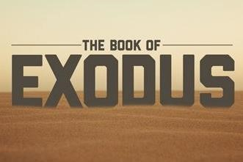

An Invitation to a Zoom Bible Study: The Book of Exodus, online, led by Rev. Kim at Mount Zion United Church

Rev. Kim Lawrence, serving at Greenwood-Mt. Zion United Church, has invited Goodwood and Claremont United members who are interested to join them for their Zoom Bible study – this is a 6-week Bible Study which is exploring the 2nd half of the Book of Exodus.

Time: Thursdays, 7-8 pm, on Zoom.
To join, email Rev. Kim Lawrence at: mountzionunitedchurch@gmail.com

Join us for Worship on our YouTube channel - CFG Worship
- Join us for worship either on Zoom, or on YouTube, Sundays at 10:30 am
- Watch past services uploaded to our YouTube channel Go to Youtube.com and search CFG Worship.

Continued Financial Support
for our Congregations
Please prayerfully consider how you can continue to support your congregation’s ongoing ministries during this time.

Offerings can be mailed to the church address itself:
PAR forms (for pre-authorized debit) are available from your church treasurer.

You can send your offering by E-TRANSFER through your online banking.

Here is where to send them:

For Claremont United send to: treasurercuc@outlook.com

For Goodwood United send to: goodwooductreasurer@gmail.com

Thank you for your continued support of our congregation’s ministry.

