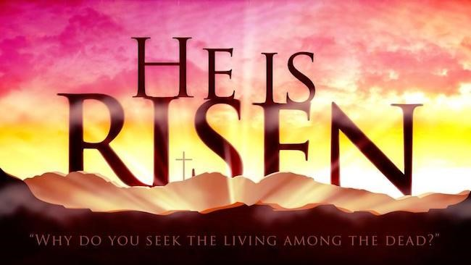
Easter Sunday
April 12, 2020
A joint Zoom worship Service with:
Claremont, Fairbank & Goodwood United Churches Leading today:
Pastor Steve Loweth & Rev. Lionel Ketola

Words of Welcome
Lighting of Christ Candle
Prelude: “Simply Alleluia” Music by: Steve Andersen and Heather Ashton

Call to Worship for Easter Morning

It was early in the morning. Still dark.
The dawn just starting to cut through the fog.
The air hung heavy with expectation, as if the earth itself were holding its breath.

The echoes of the cross linger. His voice still rings out: It Is Finished. Into your hands I commit my spirit.

The story comes to us in pieces and fragments, hints and images:

A vineyard garden, grapes ready for the harvest.

A stone, rolled away. The guards asleep at its side.

A pile of clothes, folded in an empty tomb.

Peter and John, running in with disbelief.
Walking out with questions and with hope.

But Mary stays behind. To weep in the garden.
And we weep with her. There is so much loss.
So much grief. So much death.
And yet, there’s more to the story,
A story that will unfold with surprises and new life A story that will turn the disciples’ sadness into joy!

Song – Halle Halle Halle (We open the Alleluia Box) Video Easter Greeting
One: Alleluia! Christ is Risen!
All: Christ is risen indeed! Alleluia!

Hymn: Joy Comes with the Dawn VU # 166 Video

Prayer of the day
God of resurrection,
You have rolled the stone away
And the tomb of our world has been opened wide.
With the dawn has come a new creation.
Let our celebrations today
Empty our tombs,
Renew our lives,
And release your power,
Through the risen Christ we pray. Amen

Scripture Readings

One: Whether you take what is written in the Bible as fact, metaphor, myth or story, listen now for these words and the meaning they hold in your lives.

All: May the Spirit bless us with wisdom and wonder as we ponder the meaning of these words for our lives.

First Reading: Acts 10:34-43
³⁴Then Peter began to speak to them: “I truly understand that God shows no partiality, ³⁵but in every nation anyone who fears him and does what is right is acceptable to him. ³⁶You know the message he sent to the people of Israel, preaching peace by Jesus Christ—he is Lord of all. ³⁷That message spread throughout Judea, beginning in Galilee after the baptism that John announced: ³⁸how God anointed Jesus of Nazareth with the Holy Spirit and with power; how he went about doing good and healing all who were oppressed by the devil, for God was with him. ³⁹We are witnesses to all that he did both in Judea and in Jerusalem. They put him to death by hanging him on a tree; ⁴⁰but God raised him on the third day and allowed him to appear, ⁴¹not to all the people but to us who were chosen by God as witnesses, and who ate and drank with him after he rose from the dead. ⁴²He commanded us to preach to the people and to testify that he is the one ordained by God as judge of the living and the dead. ⁴³All the prophets testify about him that everyone who believes in him receives forgiveness of sins through his name.”

Reflection: Pastor Steven

Psalm 118 Video

Sung Gospel Acclamation:
Alleluia. Lord, to who shall we go? You have the words of eternal life. Alleluia. Alleluia. Alleluia. Alleluia. Alleluia. Alleluia.

Holy Gospel: Matthew 28:1-10
28After the sabbath, as the first day of the week was dawning, Mary Magdalene and the other Mary went to see the tomb. ²And suddenly there was a great earthquake; for an angel of the Lord, descending from heaven, came and rolled back the stone and sat on it. ³His appearance was like lightning, and his clothing white as snow. ⁴For fear of him the guards shook and became like dead men. ⁵But the angel said to the women, “Do not be afraid; I know that you are looking for Jesus who was crucified. ⁶He is not here; for he has been raised, as he said. Come, see the place where he lay. ⁷Then go quickly and tell his disciples, ‘He has been raised from the dead, and indeed he is going ahead of you to Galilee; there you will see him.’ This is my message for you.” ⁸So they left the tomb quickly with fear and great joy, and ran to tell his disciples. ⁹Suddenly Jesus met them and said, “Greetings!” And they came to him, took hold of his feet, and worshiped
him. ¹⁰Then Jesus said to them, “Do not be afraid; go and tell my brothers to go to Galilee; there they will see me.”

One: Holy Wisdom, Holy Word All: Thanks be to God!

Reflection: Rev. Lionel

Hymn: In the Bulb There is a Flower Video

The Offering of our Gifts
Today we continue to not pass around the offering plate but instead we pass around our love to one another just as our Risen Christ does for us. We offer ourselves to you, O God, so that You can help us be the love and support needed for each other. We pray this in the name of the Risen One. Amen.

Prayers of the People
We praise you, living God, with songs and prayers and listening hearts and lives.

You have created and are creating, bringing life and hope and love.

You come in Jesus, your Word made flesh, to reconcile and make new.

In this new time where isolation, unexpected change,
grief and loss gets all the headlines your Holy Spirit summons us to be people shaped by your power to work resurrection.

We are not sure we believe as fully as we think we should.
We are not sure we trust as deeply as we think you require.
But we bring who we are and what we have become into your presence, longing to know your grace and your love.

During this time we know that many are in pain. Many are feeling so lonely being isolated on their own. Many are having to self isolate because they have tested positive to this virus and are living with fever and perhaps fear at where it will lead them to. We pray for your healing presence in their lives.

We pray and give thanks for all front-line workers. They put their health in risk helping those who are sick with this terrible virus.

We pray for our churches and give thanks for this way of worshipping in this time. We give thanks for the ability to draw the circle wider by engaging ourselves in worship is such a different way but knowing that we are reaching out to some many more who might otherwise not be able to join us in our church buildings.

On this day of Easter, fill us with the joy of new life, so that we can live out these days knowing that we are not alone.

Tender God, at this time we lift up all those who are in our prayers this day ….

God of new life, may we follow wherever your Spirit may lead. May we love with the love of the Risen One flowing through us. and may we - body, mind and spirit - be children of resurrection, children of hope, and children of grace.

Into your hands we commend all for whom we pray; trusting in Jesus, who showed us your Mothering love, who taught us to pray:

Lord’s Prayer

Closing Hymn: I am the Lord of the Dance Video

An Easter Blessing
What the angels said was true - and it is true today.

Christ is alive!
His heart beats in victory.
Easter is announced by every breath that we take - for the Risen One is present with us, living and moving through us to heal and transform our world.

May we go forth to be God’s Easter people – and the blessing of God: Creator, Christ and Holy Spirit be with us now and always!
All: Amen!

