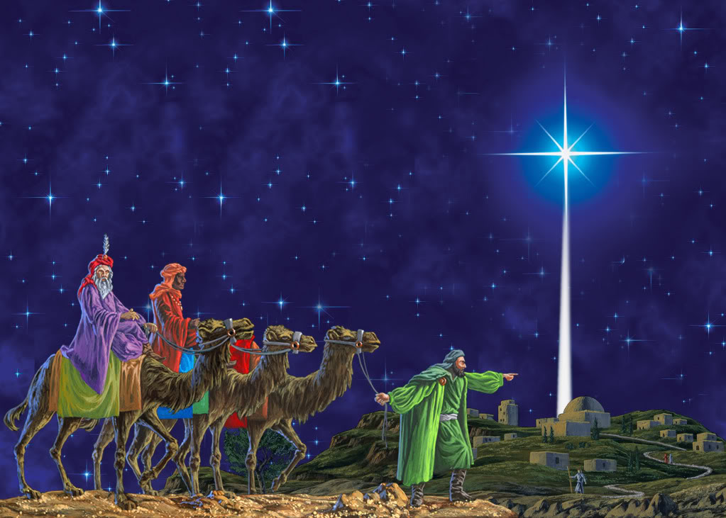
Welcome to worship!

January 3rd 2021

Epiphany Sunday

A joint online Zoom worship Service with Claremont, Fairbank & Goodwood United Churches & friends.

Worship Leaders: Pastor Steven Loweth, DLM & Rev. Lionel Ketola, M Div

Onelicense # A-723979 CCLI # 11550809

Musicians: From Claremont United Church: Gabrielle Untermann, Jane Plewman, Julia Shatford, Barb Gilbert, Steve May, otherwise known as “The Masked Bandits”.

We Joyfully Gather in God’s Presence

Words of Welcome

Lighting the Christ Candle
There was a man named Jesus, who brough hope and healing to all he met. And he said “I am the light of the World”.

Acknowledgement of the Land

On this day of Epiphany we continue the celebration of Jesus’ birth with the coming of the Magi. We honour their story and the gifts they brought the Christ child. This morning we also acknowledge the gift of this land, and the First Nations People who are the traditional custodians of the land where each of us gather today.

God of all creation, may we experience reconciliation with You, with ourselves, and with the First Nations who are the traditional custodians of this land. Amen.

Call to Worship

People of God, arise, shine,

for your light has come!
The light of Christ has come into the world.
Emmanuel.
God with us.

So arise, shine,
and we will follow the light–
when it shines brightly in the night sky

We will follow the light–
even when the path is unfamiliar

and the star rests above a dubious-looking manger.
We will lift up our eyes and look around.
And when we see the Christ child,
may our hearts be overwhelmed with joy
for the journey which brings us, finally, to the heart of God.

Carol: The First Nowell VU 91 Video

Prayer of the Day
O Star-flinging God,
whose light dances across eternity,
you lead the magi to the Christ by the leading of a star.
As we gather on this day,
dazzle us into your presence and
open our hearts to the mystery of your love.
Reveal to us what is possible, but not yet present.
And bring us at last to the full vision of your glory,
through Jesus Christ the child of hope. Amen

We Open our Hearts to the Spirit’s Voice

One: And the Word became flesh and made his dwelling among us. We have seen his glory, the glory of the one and only Son, who came from God, full of grace and truth.
All: May the Spirit bless us with wisdom and wonder, as we ponder the meaning of these words in our lives.

Isaiah 60:1-9
Arise, shine; for your light has come, and the glory of the Lord has risen upon you. For darkness shall cover the earth, and thick darkness the peoples; but the Lord will arise upon you, and his glory will appear over you. Nations shall come to your light, and kings to the brightness of your dawn. Lift up your eyes and look around; they all gather together, they come to you; your sons shall come from far away, and your daughters shall be carried on their nurses’ arms. Then you shall see and be radiant; your heart shall thrill and rejoice, because the abundance of the sea shall be brought to you, the wealth of the nations shall come to you. A multitude of camels shall cover you, the young camels of Midian and Ephah; all those from Sheba shall come. They shall bring gold and frankincense, and shall proclaim the praise of the Lord. All the flocks of Kedar shall be gathered to you, the rams of Nebaioth shall minister to you; they shall be acceptable on my altar, and I will glorify my glorious house. Who are these that fly like a cloud, and like doves to their windows? For the coastlands shall wait for me, the ships of Tarshish first, to bring your children from far away, their silver and gold with them, for the name of the Lord your God, and for the Holy One of Israel, because he has glorified you.
Holy Wisdom, Holy Word. Thanks be to God.
Pastor Steven: A Reading from Ann Weems
Carol: Arise, Your Light is Come VU 79 VIDEO

The Holy Gospel According to Matthew 2:1-15
2In the time of King Herod, after Jesus was born in Bethlehem of Judea, wise men from the East came to Jerusalem, ²asking, “Where is the child who has been born king of the Jews? For we observed his star at its rising, and have come to pay him homage.” ³When King Herod heard this, he was frightened, and all Jerusalem with him; ⁴and calling together all the chief priests and scribes of the people, he inquired of them where the Messiah was to be born. ⁵They told him, “In Bethlehem of Judea; for so it has been written by the prophet: ⁶‘And you, Bethlehem, in the land of Judah, are by no means least among the rulers of Judah; for from you shall come a ruler who is to shepherd my people Israel.’” ⁷Then Herod secretly called for the wise men and learned from them the exact time when the star had appeared. ⁸Then he sent them to Bethlehem, saying, “Go and search diligently for the child; and when you have found him, bring me word so that I may also go and pay him homage.”
⁹When they had heard the king, they set out; and there, ahead of them, went the star that they had seen at its rising, until it stopped over the place where the child was. ¹⁰When they saw that the star had stopped, they were overwhelmed with joy. ¹¹On entering the house, they saw the child with Mary his mother; and they knelt down and paid him homage. Then, opening their treasure chests, they offered him gifts of gold, frankincense, and myrrh. ¹²And having been warned in a dream not to return to Herod, they left for their own country by another road.
¹³Now after they had left, an angel of the Lord appeared to Joseph in a dream and said, “Get up, take the child and his mother, and flee to Egypt, and remain there until I tell you; for Herod is about to search for the child, to destroy him.” ¹⁴Then Joseph got up, took the child and his mother by night, and went to Egypt, ¹⁵and remained there until the death of Herod. This was to fulfill what had been spoken by the Lord through the prophet, “Out of Egypt I have called my son.”
Holy Wisdom, Holy Word Thanks be to God
Video Message: Rev. Lionel

Hymn of the Day: Will You Come and See the Light VU 96 Video

Invitation to the Offering

Prayer of Dedication for the Gifts:
God of love,
as we kneel before the cradle of your mystery
what gift can we offer
but to open up our hearts
and let your love
reshape our very lives.
May the gifts that we offer this night
bring healing and hope to our aching world.
We pray in Jesus’ name, amen.

Prayers of the People

Gathered with all who seek the Christ child, let us pray for the church, the world and all who are in need……..

Silence

Faithful God, we pray for our church that we faithfully witness to God’s love while so many people are struggling and suffering during this pandemic. May we live our mission, as the body of Christ, so that all may experience Christ’s compassion for the world.

God in Your love, Hear our Prayer

Creating God, your glory shines around us in every star, creature and person. Liberate us from the ways that we destroy your creation so that we can be free to care for the earth so that all can experience your bountiful goodness.

God in Your mercy, Hear our Prayer

God of Justice, give the leaders of the world humble courage to defend the cause of the poor and give deliverance to those in need, so that peace can abound in all countries.

God in Your mercy, Hear our Prayer

By the guidance of the star, you led the magi to pay homage to the Christ child. Protect new families, those who live alone, travelers, those who suffer loss, the homeless, the hungry, the distraught, and all others in need.

God in Your love, Hear our Prayer

Emmanuel, in Christ we boldly come before you in worship. Nurture and encourage all who are gathered for worship, this morning, so that we can live out our calling to be your church full of faith and love.

God in Your Love, Hear our Prayer

During this time of pandemic, we pray for all who are feeling weary, isolated and alone, and for all who are ill, or grieving. May they know your restoring presence through our acts of care and compassion. God in your love, hear our prayer.

At this time we offer our prayers for those people and places in our world whose needs are close to our hearts at this time … prayers of intercession are offered

Into your hands, tender God, we commend all for whom we pray, trusting that your love manifest in the Christ Child can bring hope and wholeness to our lives and our world. Amen.

With our Saviour Christ, we pray together: “God our Mother and Father in Heaven …”

We Go Forth to Love and Serve our Neighbours

Carol: As with Gladness Men of Old VU 81 Video (The Masked Bandits)

Blessing & Commissioning

It is not over.
There are always newer skies
into which God can throw stars.

Go out today with hearts full of love
waiting for God
while listening, always listening
for Angels words.

May the Blessing of God
The love of the Christ child
And the power of the Holy Spirit
Be with you all. Amen.

Sung Dismissal: Let there Be Peace on Earth VIDEO

Church Announcements
on next page …

Weekly Church Programs

Goodwood United Church & Claremont United Church:
Online Community Check-in: Tuesdays at 10:00 AM, on Zoom. Resumes Tues Jan 5th. Once our check-in time has come to a conclusion, the group will proceed with our weekly Bible Study / “Conversations about Life”, so feel free to join us for this as well.

The Knit-Wits: This is Goodwood United Church’s weekly ZOOM group for Knitting, crochet and other needle craft. This group leads our congregation’s Prayer Shawl Ministry. To find out how to connect with this group on Zoom, contact Shirley Baster.

Claremont United Church:
Wednesdays @ 12:00 noon - Join us for a Zoom “drop-in” meeting. Resumes Wed January 6th. Everyone is invited to join us for these “Virtual Brock Café” Zoom gatherings to connect with our congregational community.

Joint BOOK STUDY GROUP for all 3 Churches & friends: Friday Mornings at 10 AM

Beginning Friday January 8th to Friday Feb 12 we will read:
Unsettling the WORD: Biblical Experiments in Decolonization, Steve Heinrichs Editor.
(Available online through a variety of bookstores).

Lent Book Study (5 weeks)
Beginning the first week in Lent (Friday Feb 19th) we will read:
The Death of Christ for Progressive Christians, by Donald Schmidt.
You can order your copy through: www.woodlakebooks.com

YOUTUBE – Watch worship LIVE, Sunday Mornings at 10:30 am on YOUTUBE, or watch recordings of our Sunday service anytime during the week. See this Link (Fairbank United’s Youtube channel):
https://www.youtube.com/channel/UC1HPD2ai10bo-qbNaXvNVtw

Continued Financial Support for our Congregations
Please prayerfully consider how you can continue to support your congregation’s ongoing ministries during this time.
- Offerings can be mailed to the church address itself
- PAR forms (for pre-authorized debit) are available from your church treasurer
- You can send your offering by E-TRANSFER through your online banking. Here is where to send them:
For Claremont United send to: treasurercuc@outlook.com
For Goodwood United send to: goodwooductreasurer@gmail.com
Thank you for your continued support of our congregation’s ministry.

Find us online!
Check out our websites!
Check out our church websites for new updates during this time, including
Sunday devotions, and information about coping with stress during COVID-19.
www.claremontunitedchurch.com
www.goodwoodunitedchurch.com

Find us on Facebook!
https://www.facebook.com/goodwoodunited
https://www.facebook.com/claremontunited

PLEASE SHARE THE POSTER BELOW!

Computer Savvy?
Looking for a
Volunteer opportunity?
Need Co-op / Volunteer Hours for School?

Claremont, Fairbank and Goodwood United Churches
are seeking a
Geek Squad / Tech Volunteer
to help out with the technical aspects
of our Joint Sunday morning Zoom Worship Services at 11:00 am.

Your time, efforts and skills will help ensure that the
technical aspects of our Zoom Worship Service run smoothly.
Your role could be carried out remotely, from home, if needed.
In return, you would get volunteer hours
& the satisfaction of knowing you made a difference!
Knowledge of MS Word, PPT, and Zoom would be helpful.

Interested? Get in touch!
Contact Rev. Lionel Ketola at: lionelketola@gmail.com
Church phone: 905 649 1363

