Continued Financial Support
for our Congregation
Thank you for your continued support of our congregation’s ministries!

Offerings can be mailed to the church address to:
Claremont United Church
5052 Old Brock Rd, Claremont, ON L1Y 1B3

PAR forms (for pre-authorized debit) are available from our church treasurer, Ron Trewin.

To send your offering by e-transfer to Claremont United Church, please send it to: treasurercuc@outlook.com

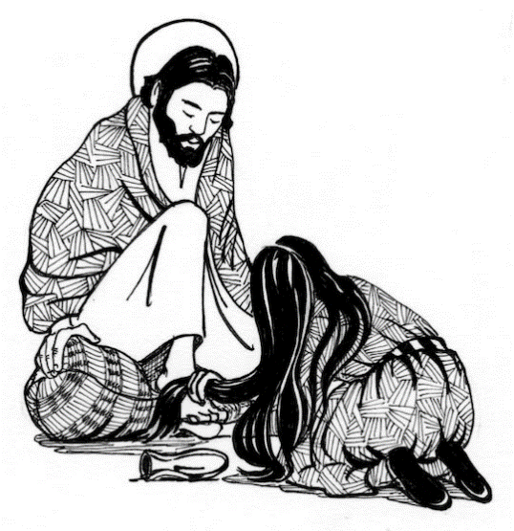Claremont United Church
www.claremontunitedchurch.com
Church office: 905 649 1363
Minister: Rev. Lionel Ketola, BA, M. Div.
Minister of Music: Gabrielle Untermann
Sunday April 3, 2022, 11:00 am service
Fifth Sunday of Lent: “The Anointing at Bethany”

GATHERING

Prelude & candle lighting – Ukrainian Anthem
Words of Welcome

Acknowledgement of the Land
We begin our worship by acknowledging the traditional custodians of the land where we are gathered for worship today. These lands remain home to a number of Indigenous nations and people. Their relationship with the land remains central to their lives.
Claremont United Church lies within the area covered by the Williams Treaties of 1923, between Canada, Ontario, and the Chippewas of Beausoleil, Georgina Island and Rama and the Mississaugas of Alderville, Curve Lake, Hiawatha and Scugog Island First Nations.
God of hope, awaken us to new opportunities to walk in justice and reconciliation with the First People of this land. Amen.

Lighting the Christ Candle
There was a man named Jesus who embodied God’s radical and inclusive love in such surprising and healing ways.
And he said: “I am the Light of the World”
Call to Worship
The Lord has made a way in the sea, a path in the mighty waters.
God is doing a new thing!
Our mouths will be filled with laughter, our tongues with shouts of joy.
God is doing a new thing!
May those who sow in tears reap with shouts of joy.
God is doing a new thing!
May those who go out weeping come home with shouts of joy.
God is doing a new thing!
Let us gather for worship filled with hopeful expectation!

Opening Hymn: VU 372 Thou I May Speak

Prayer of the Day

Extravagant God,
lavishing your love
on our poverty of heart:
inspire us to give without holding back,
to lose life
that we might find it again,
so the world will be filled
with the fragrance of your love;
through Jesus Christ,
who offers himself for us. Amen.

WORD

Time with the Children

Song with the Children: VU 365 Jesus Loves Me

Scripture Readings
Whether you take what is written in the Bible as fact, metaphor, myth or story, listen now to these words of scripture and for the meaning that they hold in your lives today.
May God bless us with wisdom and wonder as we listen for the Spirit’s voice through these words of scripture.

First Reading: Isaiah 43: 16-21
Psalm 126 VU page 850 (Refrain 2)
Holy Gospel: Luke 15: 1-3, 11b – 32.

Sermon: Rev. Lionel

Hymn: MV 144 Like A Healing Stream

Minute for Mission

Invitation to the Offering

Sung Offering Verse: VU 540

Grant us, God, the grace of giving,
with a spirit large and free,
that ourselves and all our living
we may offer faithfully.

Prayer of Dedication for the Gifts

Loving God, as Mary offered Jesus the gift of her extravagant care, may the gifts that we offer this day lavish our world with love, compassion and justice; in Jesus’ name we pray. Amen.

Prayers of the People
- Opening prayer
- Prayers of intercession
- Sung Lord’s Prayer VU 959

SENDING

Closing Hymn: VU 642 Be Thou My Vision

- Joys and Celebrations
- Announcements

Blessing and Commissioning

Sung Blessing:

MV # 214 May God’s Sheltering Wings

May God’s Sheltering Wings
Her gathering wings protect you,
May God’s nurturing arms,
Her cradling arms sustain you,
And hold you in her love.
And hold you in her love.

