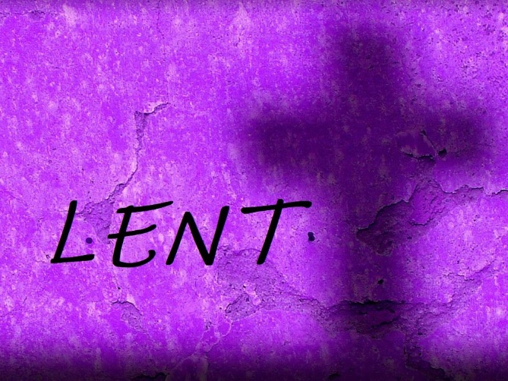***Welcome* *to worship!***

**March 21st 2021 / Lent 5**

**HOLY COMMUNION**

***A joint online Zoom worship Service with Claremont, Fairbank & Goodwood United Churches & friends.***

**Guest Speaker: David Morley, President and CEO, UNICEF Canada**

***Worship Leaders:*** *Pastor Steven Loweth, DLM & Rev. Lionel Ketola, BA, M Div.*

Onelicense # A-723979 CCLI # 11550809

**GATHERING**

**Words of Welcome**

**Lighting the Christ Candle**

There was a man named Jesus, who brought hope and healing to all he met.

And he said **“I am the light of the World”.**

**Acknowledgement of the Land**

As we begin our worship, we acknowledge the traditional custodians of the land where each of us is gathered today. We pay our respects to the Elders past, present and emerging, for they hold the memories, the traditions, the culture and the hopes of all Indigenous peoples on Turtle Island.

**God of justice, help us to embody your call to reconciliation with our First Nations in tangible, loving ways. Amen.**

**Introit: God Be in My Head VU 430 Video**

**God be in my head, and in my understanding;  
God be in mine eyes, and in my looking;  
God be in my mouth, and in my speaking;  
God be in my heart, and in my thinking;  
God be at mine end, and at my departing.**

**Prayer of the Day (in unison)**

*Let us pray:*

O God, who makes all things new,  
new stars, new dust, new life;  
take my heart,  
every hardened edge and measured beat,  
and create something new in me.

I need your newness, God,  
the rough parts of me made smooth;  
the stagnant, stirred;  
the stuck, freed;  
the unkind, forgiven.

And then, by the power of your Spirit,

I need to be turned toward Love again. Amen.

~ by Pamela C. Hawkins, in *The Awkward Season: Prayers for Lent*

**Opening Hymn: VU 686 God of Grace and God of Glory (by the Masked Bandits)**

**CONFESSION**

We are beloved children of God, on a journey towards healing and wholeness.

Let us pause to acknowledge both the blessedness, and the brokenness in our lives and in our world. *Silent confession*

**Have we trials and temptations?  
Is there trouble anywhere?  
We should never be discouraged;  
take it to the Lord in prayer.  
Can we find a friend so faithful,  
who will all our sorrows share?  
Jesus knows our every weakness;  
take it to the Lord in prayer.**

**Assurance of God’s Forgiveness**

The wilderness and the dry land shall be glad,

the desert shall rejoice and blossom;

like the crocus, the desert shall blossom abundantly,

and rejoice with joy and singing.

God comes to us in the desert of our struggles

with words of grace and forgiveness.

We are a forgiven people;

God’s Spirit is free among us! Thanks be to God!

**WORD**

One: Whether you take what is written in the Bible as fact, metaphor, myth or story, listen now to these words for the meaning they hold in your lives today.

**All: May the Spirit bless us with wisdom and wonder, as we ponder the meaning of these words in our lives.**

**Jeremiah 31:27-34**

27The days are surely coming, says the Lord, when I will sow the house of Israel and the house of Judah with the seed of humans and the seed of animals. 28And just as I have watched over them to pluck up and break down, to overthrow, destroy, and bring evil, so I will watch over them to build and to plant, says the Lord. 29In those days they shall no longer say: “The parents have eaten sour grapes, and the children’s teeth are set on edge.” 30But all shall die for their own sins; the teeth of everyone who eats sour grapes shall be set on edge.

31The days are surely coming, says the Lord, when I will make a new covenant with the house of Israel and the house of Judah. 32It will not be like the covenant that I made with their ancestors when I took them by the hand to bring them out of the land of Egypt—a covenant that they broke, though I was their husband, says the Lord. 33But this is the covenant that I will make with the house of Israel after those days, says the Lord: I will put my law within them, and I will write it on their hearts; and I will be their God, and they shall be my people. 34No longer shall they teach one another, or say to each other, “Know the Lord,” for they shall all know me, from the least of them to the greatest, says the Lord; for I will forgive their iniquity, and remember their sin no more.

Holy Wisdom, Holy Word **Thanks be to God**

Scripture Song: MV 79 Spirit Open my Heart (Chorus, verse 2, chorus).

Music: Alex Hunyh Do

**John 12:20-36**

20Now among those who went up to worship at the festival were some Greeks. 21They came to Philip, who was from Bethsaida in Galilee, and said to him, “Sir, we wish to see Jesus.” 22Philip went and told Andrew; then Andrew and Philip went and told Jesus. 23Jesus answered them, “The hour has come for the Son of Man to be glorified. 24Very truly, I tell you, unless a grain of wheat falls into the earth and dies, it remains just a single grain; but if it dies, it bears much fruit. 25Those who love their life lose it, and those who hate their life in this world will keep it for eternal life. 26Whoever serves me must follow me, and where I am, there will my servant be also. Whoever serves me, the Father will honor.

27“Now my soul is troubled. And what should I say—‘Father, save me from this hour’? No, it is for this reason that I have come to this hour. 28Father, glorify your name.” Then a voice came from heaven, “I have glorified it, and I will glorify it again.” 29The crowd standing there heard it and said that it was thunder. Others said, “An angel has spoken to him.” 30Jesus answered, “This voice has come for your sake, not for mine. 31Now is the judgment of this world; now the ruler of this world will be driven out. 32And I, when I am lifted up from the earth, will draw all people to myself.” 33He said this to indicate the kind of death he was to die. 34The crowd answered him, “We have heard from the law that the Messiah remains forever. How can you say that the Son of Man must be lifted up? Who is this Son of Man?” 35Jesus said to them, “The light is with you for a little longer. Walk while you have the light, so that the darkness may not overtake you. If you walk in the darkness, you do not know where you are going. 36While you have the light, believe in the light, so that you may become children of light.” After Jesus had said this, he departed and hid from them.

Holy Wisdom, Holy Word **Thanks be to God**

**Message: David Morley, President and CEO, UNICEF Canada**

**Hymn of the Day: VU 598 When Pain of the World**

**Prayers of the People**  *By Jann Aldredge-Clanton, USA*

Trusting in the promises of God, let us pray for the church, the world, and all who are in need. *A brief silence is kept*

Renewing God, write your new covenant of love in our hearts. Renew your church so we can be the beloved community you call us to be. Help us to model listening, understanding, and a joyful celebration of diversity so all your creation can be reconciled into one.

God in your love, **hear our prayer.**

You fill the earth – from tiny grains of wheat to the mighty thunder – with your presence, and you call us to care for your creation. Grant weather that prepares the soil for seeds; protect all from violent storms, flooding and wildfires. Make us agents of your compassion for all who are affected by climate disasters.

God in your love, **hear our prayer.**

You promise to write your law on our hearts. Guide citizens throughout the world to shape communities that reflect your justice, mercy and peace, and give them creativity to work for the welfare of all.

God in your love, **hear our prayer.**

Jesus calls us to follow him in life and in death. Empower us for lives of risk-taking discipleship. Give us courage and faith to follow Jesus wherever he leads.

God in your love, **hear our prayer.**

Tender God, at this time, we lift up our prayers for all who are in need:

*Intercessions are spoken*

*Into your hands, Loving God, we commend all for whom we pray; trusting in your great love for us, through Jesus who taught us to pray:*

***God our Heavenly Parent, hallowed be thy name … Amen.***

**Offertory Prayer**

*Let us pray:*

**Loving God, We offer to you what you have first given us –**

**our selves, our time, our possessions – signs of your gracious love.**

**Receive all of our gifts for the sake of the One**

**who emptied himself for us – Jesus our brother. Amen.**

**TABLE**

**HOLY COMMUNION**

May the God of grace and welcome be with you

**And also with you**

Lift up your hearts

**We lift them up in joyful praise**

Let us give thanks to our God

**May our whole lives be a song of thanksgiving**

We live in a world in which we can often feel like strangers- not sure where we truly belong.

**And then we gather at Jesus’ table, and in the mystery of the bread and the wine, something new takes root in our hearts,**

**and we know - in a new way - that we are indeed at home.**

Blessed are you, Creator of life, and lover of us all.

You call us into renewed relationship with you and with one another.

In Jesus, you showed us the gift and true power of vulnerability -

**A vulnerable love that reaches out in solidarity with all who suffer.**

Jesus healed the sick, befriended the outcast, challenged the unjust systems of his day, and gathered all of your people into one great feast of life…

**so we can all be channels of God’s transforming love.**

On the night that Jesus was betrayed ….

Remembering the depth of your love for us in Jesus, we offer ourselves to you in joyful gratitude. May all that we say and do proclaim the mystery of our faith:

**Christ has died.**

**Christ has risen.**

**Christ will come again.**

Send your life-giving Spirit upon us, and upon these gifts of bread and cup, O God.

**May we who share these gifts be the living and loving body of Christ - your hands and heart for our broken world.**

*At the Breaking of the Bread:*

Holy things for holy people! **Thanks be to God!**

Prayer after communion:

**We give you thanks, Loving God, that you have refreshed us**

**through the healing power of this gift of life.**

**Send us from this table to tables throughout our world,**

**to love and serve in Jesus’ name. Amen.**

**Closing Hymn: VU 595 We Are Pilgrims**

**Blessing and Commissioning**

May God bless you with a new heart,

a transformed heart,  
a heart that knows in the depths of its being

the love, justice and mercy of God.

May the blessing of God,

Creator, Christ and Holy Spirit

Be with you now and always. Amen.

***Church Announcements – see below***

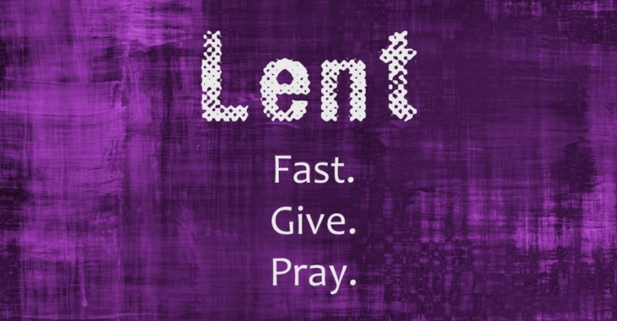Pledges

for

Plumpies

**A Lent Fundraiser**

**for UNICEF**

**What are Plumpies?**

Each donation of $10.00 will provide a child suffering from malnutrition with enough Plumpy’Nut for one week. Plumpy’Nut is a “miracle food” – a paste made of peanuts, powdered milk, sugar and oil, with added vitamins and minerals. Three 500 calorie packs a day can restore a malnourished child to health in a few weeks. Plumpy’Nut requires no added water or refrigeration, can be eaten with fingers and is tolerated by malnourished bodies. All monies raised will go to UNICEF to purchase and distribute this edible miracle.

**How does this Fundraiser work?** Decorate a jar or basket for Lent to put your Pledges in. Each Sunday of Lent, write down what you have pledged to donate to Plumpies for that week and put it in your Lent jar / basket. **At Easter, add up your pledges and send your donation** to your congregation. All monies will be forwarded to UNICEF Canada’s Plumpy’Nut program.

How to send your money: Send your donation to the church, or send your donation by interac e-transfer to:

for Goodwood United Church: [**goodwooductreasurer@gmail.com**](mailto:goodwooductreasurer@gmail.com)

for Claremont United Church: [**treasurercuc@outlook.com**](mailto:treasurercuc@outlook.com)

**Evening Prayer During Lent**

**Every Tuesday Evening**

**at 7:30 pm**

*Upcoming Services:*

Tues March 23, 7:30 pm

Tues March 30, 7:30 pm (Holy Week)

**Note: For Evening Prayer, we use the Sunday Zoom Link from the previous Sunday’s Service. Please save your Bulletin email for the link.**

**Goodwood United Church - Weekly Programs & Meetings**

**Online Community Check-in: Tuesdays at 10:00 AM, on Zoom.** Join us for an opportunity to connect and find supportive community through our regular weekly check-in meetings. At the conclusion of our check-in time, we move into our weekly **“Conversations about Life / Not your Typical Bible Study” group**. Feel free to join us!

**The Knit-Wits:** **Wednesdays at 10:00 am**. This is **Goodwood United Church’s weekly ZOOM group** for Knitting, crochet and other needle craft. This group facilitates our congregation’s **Prayer Shawl Ministry**. They will keep you in stitches! To find out how to connect with this group on Zoom, contact Shirley Baster.

**Book Study: Fridays at 10:00 am on Zoom – See Below for details of our Lent Study.**

**CLAREMONT UNITED CHURCH - Weekly Programs and Meetings**

**Wednesdays @ 12:00 noon – Join us for a Zoom “drop-in” meeting.**

Everyone is invited to join us for these “Virtual Brock Café” Zoom gatherings to connect with our congregational community, catch up with each other and to share support.



**Join our joint BOOK STUDY GROUP**

**for all 3 Churches & friends:**

**Friday Mornings at 10:00 AM on Zoom.**

Beginning the first week in Lent (Friday Feb 19th) we will read:

**The Death of Christ for Progressive Christians, by Donald Schmidt.**

**You can order your copy through:** **www.woodlakebooks.com**

* **Friday March 26th at 10:00 will be our last session.**
* **We will break for 2 weeks**
* **We will resume meeting on Friday April 16, 10:30 am to continue our reading in the book: UNSETTLING the WORD: Biblical Experiments in Decolonization.**

**Join us for Worship on YOUTUBE**

**Join us on our NEW CFG Worship YouTube Channel for all 3 Churches:**

[https://studio.youtube.com/channel/UCSwegSn9y2rGxyVFtdGGtxA/videos/live?filter=%5B%5D&sort=%7B%22columnType%22%3A%22date%22%2C%22sortOrder%22%3A%22DESCENDING%22%7D](https://studio.youtube.com/channel/UCSwegSn9y2rGxyVFtdGGtxA/videos/live?filter=%5B%5D&sort=%7B%22col)

or go to Youtube.com and search **CFG Worship**.

Please also click the subscribe button.

**For past services**, please see this Link **(Fairbank United Church’s YouTube channel):**

https://www.youtube.com/channel/UC1HPD2ai10bo-qbNaXvNVtw

**Continued Financial Support**

**for our Congregations**

Please prayerfully consider how you can

continue to support your congregation’s

ongoing ministries during this time.

* Offerings can be **mailed to the church address** itself
* **PAR forms** (for pre-authorized debit) are available from your church treasurer
* You can send your offering by **E-TRANSFER** through your online banking. **Here is where to send them:**

For **Claremont United** sendto**: treasurercuc@outlook.com**

For **Goodwood United** sendto: **goodwooductreasurer@gmail.com**

***Thank you for your continued support of our congregation’s ministry.***