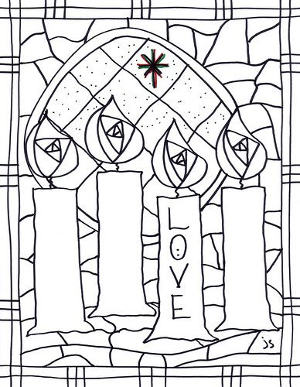

The Fourth Advent candle is for LOVE – God’s love for us!

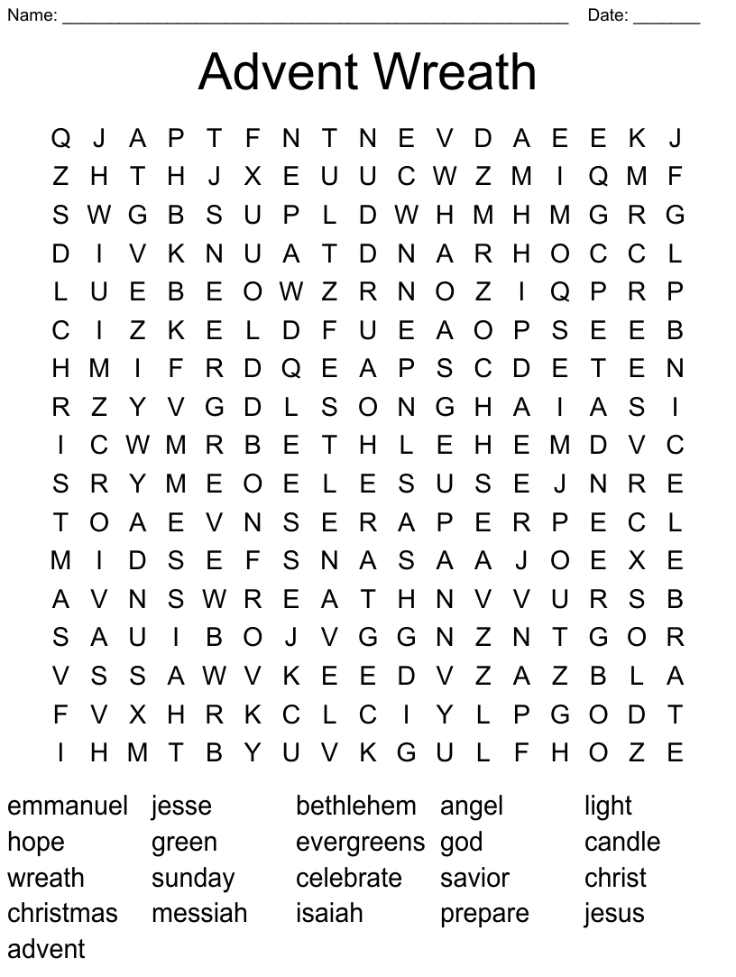

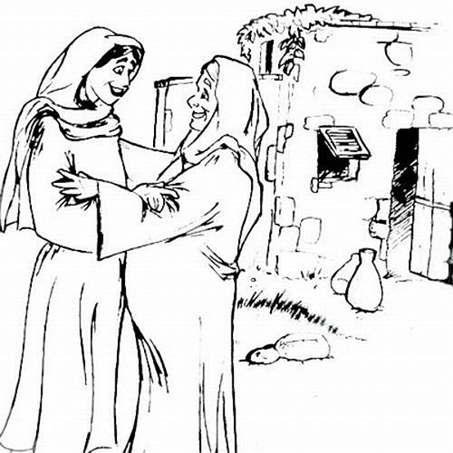

Mary Greets Elizabeth: Luke 1: 39 – 45
The Fourth Sunday of Advent

