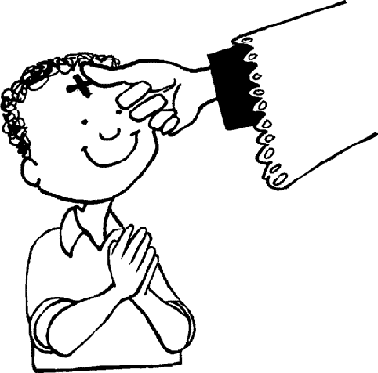

On Ash Wednesday, the minister marks our foreheads with a cross made of ashes. The ashes remind us that God created us from the good earth. As children of the earth, we are called to humbly walk on the earth with love.
