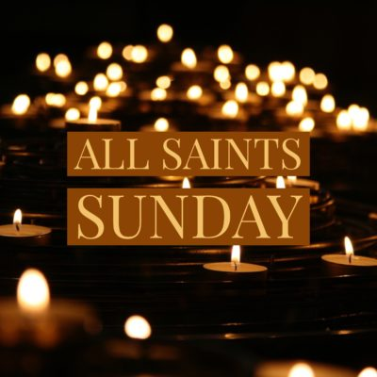
Welcome to worship!

Sunday November 7th, 2021

24th Sunday after Pentecost

All Saints Sunday

A joint online Zoom worship Service with:

Claremont, Fairbank & Goodwood United Churches and Guests

Worship Leaders: Pastor Steven Loweth & Rev. Lionel Ketola
Onelicense # A-723979 CCLI # 11550809

Welcome

We Joyfully Gather in God’s Presence

Lighting the Christ Candle
There was a man named Jesus, who embodied God’s love and compassion in such surprising ways. And he said: I am the light of the world

Acknowledgement of the Land
As we begin our worship, we acknowledge the history, spirituality and cultures of the First Nations who are the traditional custodians of the land where each of us is gathered today. Their relationship with the land remains central to their lives.
God of new life, ground us in love and justice so we can work toward reconciliation and fulfill our treaty obligations with the First Peoples of this land. Amen.

Call to Worship
Come all who are weary
of wealth, of poverty, of power, of struggle, of division
Come all who are heavy-laden
with too much, with too little, with anxiety, with fear, with anger
Come all who have hope
for liberation, for peace, for freedom, for the kingdom
Hear these words
“See, I am making all things new.”

Opening Hymn: This is God’s Wondrous World VU 296 The Masked Bandits

Gathering Prayer

Loving God, we your saints gather to worship and praise you this day.
We celebrate the saints who have served you and been an example for us
throughout the past. We give you thanks for the joy of being a part of the communion
of saints with those who have gone before and those scattered around the globe. Open us to your Spirit to continue being the saints you have called us to be. In Christ’s name we pray. Amen.

We Open our Hearts to the Spirit’s Voice

One: Whether you take what is written in the Bible as fact, metaphor, myth or story, listen now to these words for the meaning they hold in your lives today.
All: May the Spirit bless us with wisdom and wonder, as we ponder the meaning of these words in our lives.

Psalm 24 Chris Brunelle https://youtu.be/egf3Zpcnppw
Revelation 21:1-6a
21Then I saw a new heaven and a new earth; for the first heaven and the first earth had passed away, and the sea was no more. ²And I saw the holy city, the new Jerusalem, coming down out of heaven from God, prepared as a bride adorned for her husband. ³And I heard a loud voice from the throne saying, “See, the home of God is among mortals. He will dwell with them as their God; they will be his peoples, and God himself will be with them; ⁴he will wipe every tear from their eyes. Death will be no more; mourning and crying and pain will be no more, for the first things have passed away.” ⁵And the one who was seated on the throne said, “See, I am making all things new.” Also he said, “Write this, for these words are trustworthy and true.” ⁶Then he said to me, “It is done! I am the Alpha and the Omega, the beginning and the end.

Reflection: Rev. Lionel Ketola

Hymn: I See a New Heaven VU 713 https://youtu.be/gjxnLbQdRW4
John 11:32-44
³²When Mary came where Jesus was and saw him, she knelt at his feet and said to him, “Lord, if you had been here, my brother would not have died.”
³³When Jesus saw her weeping, and the Jews who came with her also weeping, he was greatly disturbed in spirit and deeply moved. ³⁴He said, “Where have you laid him?” They said to him, “Lord, come and see.” ³⁵Jesus began to weep. ³⁶So the Jews said, “See how he loved him!” ³⁷But some of them said, “Could not he who opened the eyes of the blind man have kept this man from dying?” ³⁸Then Jesus, again greatly disturbed, came to the tomb. It was a cave, and a stone was lying against it. ³⁹Jesus said, “Take away the stone.” Martha, the sister of the dead man, said to him, “Lord, already there is a stench because he has been dead four days.” ⁴⁰Jesus said to her, “Did I not tell you that if you believed, you would see the glory of God?” ⁴¹So they took away the stone. And Jesus looked upward and said, “Father, I thank you for having heard me. ⁴²I knew that you always hear me, but I have said this for the sake of the crowd standing here, so that they may believe that you sent me.” ⁴³When he had said this, he cried with a loud voice, “Lazarus, come out!” ⁴⁴The dead man came out, his hands and feet bound with strips of cloth, and his face wrapped in a cloth. Jesus said to them, “Unbind him, and let him go.”

Reflection: Pastor Steven Loweth
Hymn: Walk With Me VU 649 https://youtu.be/-P8XWadzcmc

Invitation to the Offering

Prayer of Dedication for the Gifts
God of abundance,
you cause streams to break forth in the desert
and manna to rain down from the heavens.
Accept the gifts that you have first given us.
Unite them with the offering of our lives
to nourish the world you love so dearly;
through Jesus Christ, our Saviour. Amen.

Prayers of the People
Holy One
of days and nights,
of sinners and saints,
of right and left
and everything between and beyond,
We are grateful for all Your presence
that abides in every corner of our living.

You lurk quietly in the loneliest places in our hearts,
keeping watch.
You grieve with us in our devastations,
our losses, our fears.
You journey with us in our celebrations, our defeats,
and even in the monotony of our days.
You delight in us, and love us.

May we live in that love and delight,
knowing that as we sink into You we might become more like You,
wanting life and grace for this world
and all peoples and creatures that live upon it.

We pray for this world,
for the places and precious people
who are striving to recover from hurricanes
and floods and raging fires.
We pray for peace among nations,
and make us instruments of that peace.

We pray for our children and our youth
that they may be surrounded by protection,
and also be challenged to be all of who they have been created to be.
God in Your Love, Hear our prayer

At this time, we remember all who have asked for our prayers…..

Intercessions are offered

Loving God, we give you thanks for all of the saints in our lives;
those who are living and those who have been blessed to our memory.

We now share an image of a beloved Saint that we remember today

Tender God, all of these things we ask for your loves sake, through Christ who has set us apart to be his holy people. With our Saviour Christ we pray: “God our Mother and
Father in heaven….”

Closing Hymn: For All the Saints VU 705 VIDEO
https://youtu.be/UkaocGFsA6k

Blessing
May we go forth grounded in our identity:
as the children of God,
as God’s Saints who have been set apart
to share God’s love and justice in our world.

And may the blessing of God
Creator, Christ and Holy Spirit
be with you now and always. Amen.

Sung Blessing: Go Now in Peace Emmanuel Methodist Church Choir Chennai, India https://youtu.be/_zJyFVbzY_s

Church News and Announcements

See next page
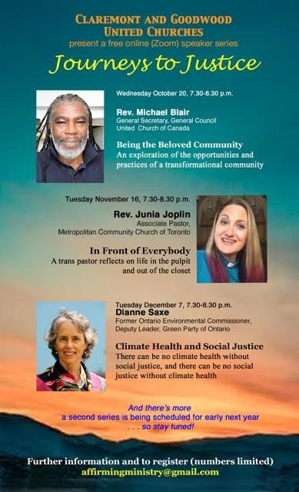
Goodwood United Church
-

Weekly Programs & Meetings

Goodwood United Church - Weekly Programs and Meetings

The Knit-Wits: Wednesdays at 10:00 am. This is Goodwood United Church’s weekly ZOOM group for Knitting, crochet and other needle craft. This group facilitates our congregation’s Prayer Shawl Ministry. They will keep you in stitches! To find out how to connect with this group on Zoom, contact Shirley Baster.

Thursday Mornings from 10-11 am - “Outdoor Coffee Gathering in the church parking lot” (Unless there is heavy rain that day). Join us outside the church (and bring your camping chair if you like) for a safe, socially distanced gathering for coffee & conversation outside of the church building. All COVID-19 precautions will be observed.

Book Study Group – Friday mornings at 10:00 am (see below for details)

Goodwood United Church Board: Thursday November 18, 11:30 am at the church

Claremont United Church - Weekly Programs and Meetings

Wednesdays at 10:00 am – Join us for our Online Zoom Check in
Enjoy a chance to connect with our church community and share stories, laughter and support for this online gathering.

Discernment Process – Please sign up to participate in a Wisdom Circle!
Earlier this year, our Claremont United Church’s Board has voted to begin a Discernment process which will use the “wisdom circle process” to discern what our future as a congregation could look like! This is a very exciting process to begin, as we seek the Spirit’s guidance about our future shape & ministries.

We are now ready to begin hosting Wisdom Circles. Please sign up to participate in this process by sending an email to Rev. Lionel at claremontunitedchurch@gmail.com.

Participants should expect to be involved in a monthly meeting for approx. 6 months’ time. You will remain in the same group for the duration of the process. Please indicate whether you would prefer to attend a daytime or evening meeting for your circle. Once we hear back from a good number of our members, we will announce the first meeting times. Looking forward to your involvement! Rev. Lionel
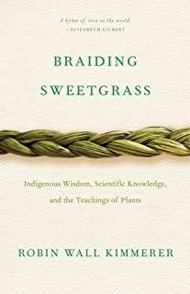
Join us for our
Friday Morning Book Study
Friday mornings at 10:00 am, on Zoom.
To get the Zoom link please contact Rev. Lionel.

Join us as we read: Braiding Sweetgrass: Indigenous Wisdom, Scientific Knowledge and the Teachings of Plants, by Robin Wall Kimmerer.

A word to newcomers: Don’t worry about joining us part way through – we are taking the book chapter by chapter with a slow reflective pace, and each chapter has its own unique theme. So there is no “right” time to join our study. So join us as we enjoy this very inspiring book!

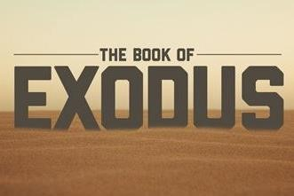

An Invitation to a Zoom Bible Study: The Book of Exodus, online, led by Rev. Kim at Mount Zion United Church

Rev. Kim Lawrence, serving at Greenwood-Mt. Zion United Church, has invited Goodwood and Claremont United members who are interested to join them for their Zoom Bible study – this is a 6-week Bible Study which is exploring the 2nd half of the Book of Exodus.

Time: Thursdays, 7-8 pm, on Zoom.
To join, email Rev. Kim Lawrence at: mountzionunitedchurch@gmail.com

Join us for Worship on our YouTube channel - CFG Worship
- Join us for worship either on Zoom, or on YouTube, Sundays at 10:30 am
- Watch past services uploaded to our YouTube channel Go to Youtube.com and search CFG Worship.

Continued Financial Support
for our Congregations
Please prayerfully consider how you can continue to support your congregation’s ongoing ministries during this time.

Offerings can be mailed to the church address itself:
PAR forms (for pre-authorized debit) are available from your church treasurer.

You can send your offering by E-TRANSFER through your online banking.

Here is where to send them:

For Claremont United send to: treasurercuc@outlook.com

For Goodwood United send to: goodwooductreasurer@gmail.com

Thank you for your continued support of our congregation’s ministry.

