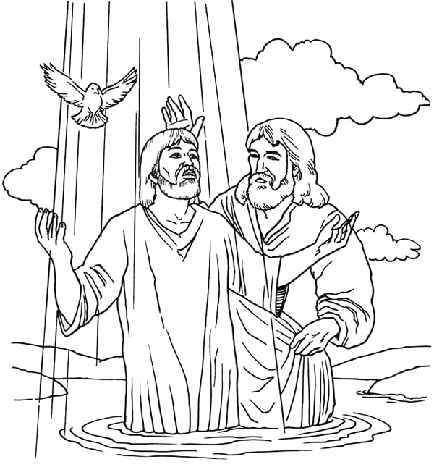
Jesus is Baptized in the Jordan River by John the Baptist

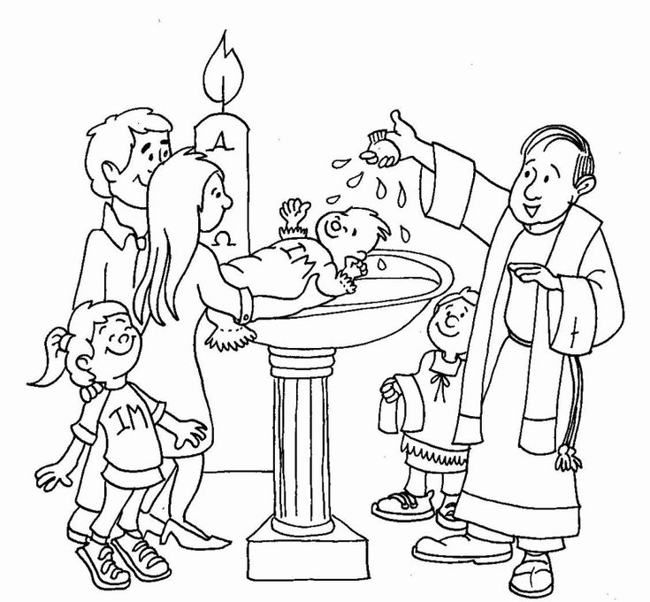

My Baptism - When God used water to tell me:
“You are my beloved child!”

