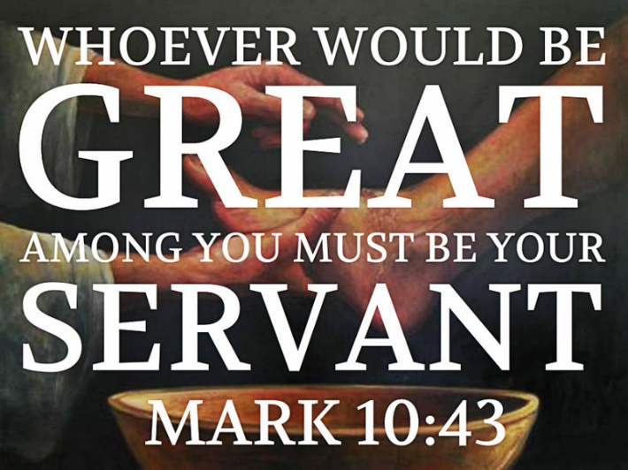
Welcome to worship!

Sunday October 17th, 2021

21st Sunday after Pentecost

A joint online Zoom worship Service with:

Claremont, Fairbank & Goodwood United Churches and Guests

Worship Leaders: Pastor Steven Loweth & Rev. Lionel Ketola
Onelicense # A-723979 CCLI # 11550809

Announcements & Today’s Worship Theme

We Joyfully Gather in God’s Presence

Lighting the Christ Candle
There was a man named Jesus, who embodied God’s love and compassion in such surprising ways. And he said: I am the light of the world

Acknowledgement of the Land
As we begin our worship, we acknowledge the history, spirituality and cultures of the First Nations who are the traditional custodians of the land where each of us is gathered today. Their relationship with the land remains central to their lives.
God of new life, ground us in love and justice so we can work toward reconciliation and fulfill our treaty obligations with the First Peoples of this land. Amen.

Opening Hymn: Come Touch Our hearts MV # 12

Prayer of the Day ~ Adapted, from a prayer by Steve Garnaas-Holmes
Holy One,
breath of the big bang,
Source of creation,
you who make life out of nothing,
breathe yourself into me.
Create me.
You are the flame, I am your light.
You are the nerve, I am your muscle.
You are the Word, I am your story.
You are the song, I am the singing.

I am one with you
and one with all Creation.
One Spirit, one flesh, many forms.
In your Spirit we are all kindred.

Holy One, live in me;
I am your body.
We are your body.
Your web of life.
Together may we find our deep and abundant life in you. Amen.

Prayer of Confession
Let us confess our sins to the one who welcomes us with an open heart.

Silence for reflection

God our comforter:
We seek out power to soothe our insecurity.
We seek places of honour, to soothe our inner doubts.
We see your abundance, and hoard it for ourselves.
We see injustice and oppression, and turn away.
We see Creation’s beauty, and exploit the earth for our own needs.

Hear our cry for renewal, O God.
Free us from our broken ways.
Teach us to walk the path of the humble Christ
who did not grasp at power, but emptied himself, in love, for the healing of all.

Sung Response: Take O Take me As I Am MV 85

Words of Assurance
Hear the good news! As the words of the Psalmist proclaim:
“Humble yourselves in the sight of the Lord, and God will lift you up”.
May we go forth, empowered by the knowledge
that God embraces us with unconditional love and forgiveness.
May the Holy Spirit daily renew us so we can follow more closely in Jesus’ way!
Thanks be to God! Amen.

We Open our Hearts to the Spirit’s Voice

One: Whether you take what is written in the Bible as fact, metaphor, myth or story, listen now to these words for the meaning they hold in your lives today.
All: May the Spirit bless us with wisdom and wonder, as we ponder the meaning of these words in our lives.

Hebrews 5:1-10

Every high priest chosen from among mortals is put in charge of things pertaining to God on their behalf, to offer gifts and sacrifices for sins. ²He is able to deal gently with the ignorant and wayward, since he himself is subject to weakness; ³and because of this he must offer sacrifice for his own sins as well as for those of the people. ⁴And one does not presume to take this honor, but takes it only when called by God, just as Aaron was. ⁵So also Christ did not glorify himself in becoming a high priest, but was appointed by the one who said to him, “You are my Son, today I have begotten you”; ⁶as he says also in another place, “You are a priest forever, according to the order of Melchizedek.”
⁷In the days of his flesh, Jesus offered up prayers and supplications, with loud cries and tears, to the one who was able to save him from death, and he was heard because of his reverent submission. ⁸Although he was a Son, he learned obedience through what he suffered; ⁹and having been made perfect, he became the source of eternal salvation for all who obey him, ¹⁰having been designated by God a high priest according to the order of Melchizedek.
Holy Wisdom, Holy Word. Thanks be to God.

Responsive Psalm Psalm 104 Video: Chris Brunelle, with permission
https://youtu.be/xTc7bO9dtPk

Mark 10:35-45
³⁵James and John, the sons of Zebedee, came forward to him and said to him, “Teacher, we want you to do for us whatever we ask of you.” ³⁶And he said to them, “What is it you want me to do for you?” ³⁷And they said to him, “Grant us to sit, one at your right hand and one at your left, in your glory.” ³⁸But Jesus said to them, “You do not know what you are asking. Are you able to drink the cup that I drink, or be baptized with the baptism that I am baptized with?” ³⁹They replied, “We are able.” Then Jesus said to them, “The cup that I drink you will drink; and with the baptism with which I am baptized, you will be baptized; ⁴⁰but to sit at my right hand or at my left is not mine to grant, but it is for those for whom it has been prepared.”
⁴¹When the ten heard this, they began to be angry with James and John. ⁴²So Jesus called them and said to them, “You know that among the Gentiles those whom they recognize as their rulers lord it over them, and their great ones are tyrants over them. ⁴³But it is not so among you; but whoever wishes to become great among you must be your servant, ⁴⁴and whoever wishes to be first among you must be slave of all. ⁴⁵For the Son of Man came not to be served but to serve, and to give his life a ransom for many.”

Holy Wisdom, Holy Word. Thanks be to God.
Sermon: Pastor Steven Loweth

Hymn of the Day: VU 149 When I Survey The Masked Bandits and Julia Shatford

Invitation to the Offering

Prayer of Dedication for the Gifts:
God of abundance,
you cause streams to break forth in the desert
and manna to rain down from the heavens.
Accept the gifts that you have first given us.
Unite them with the offering of our lives
to nourish the world you love so dearly;
through Jesus Christ, our Saviour. Amen.
Prayers for the People
Set free by God’s love and grace, let us offer our prayers for the church, the world, and all who are in need, praying: God in your love, hear our prayer.

For the servant ministry of Jesus, we praise you. Send your Holy Spirit upon your church, the body of Christ, that we might be channels of Christ’s humble love for our world. God in your love, hear our prayer.

For the lush and abundant habitat that you provide for all your creatures, we praise you. May the earth experience the healing that it yearns for, so that every creature and species throughout the earth may flourish as you intend. God in your love, hear our prayer.

Suffering One, for all who work toward peace and who lead the nations with a servant’s heart, we praise you. Bring justice for all who suffer violence, persecution, discrimination, hunger, poverty, and homelessness. May we be places of refuge, safety and advocacy for all people.
God in your love, hear our prayer.

Merciful One, for all who do the work of healing in mind, body and spirit we praise you. Surround and comfort all who struggle with depression, anxiety, cancer, or any illness, that all may know your healing presence.
God in your love, hear our prayer.

We remember all who have asked for our prayers:

Prayers of intercession are spoken

Confident in your great love for us, we entrust our prayers to you, O God, as we pray together: “God, our Mother and Father in Heaven, hallowed be thy name... Amen.”

We Go Forth to Serve our Neighbors

Hymn: This Is God’s Wondrous World VU 296

Blessing and Commissioning

As we go forth this day,
let us be reminded of the promises of scripture.
From Psalm 91:

Because you cling to me, I will deliver you;
You shall call upon me and I will answer you.
I will be with you in times of trouble;
I will deliver you and glorify you
and I will show you my salvation.

Go forth with peace and confidence,
knowing that God goes with you.

And may the blessing of God,
Creator, Christ and Holy Spirit
be with you now and always. Amen.

Sung Blessing: Go Now in Peace VIDEO

Church News and Announcements

See next page
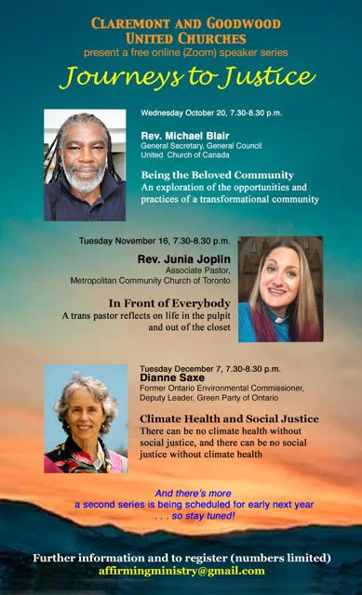
Goodwood United Church - Weekly Programs & Meetings
Goodwood United Church - Weekly Programs and Meetings

The Knit-Wits: Wednesdays at 10:00 am. This is Goodwood United Church’s weekly ZOOM group for Knitting, crochet and other needle craft. This group facilitates our congregation’s Prayer Shawl Ministry. They will keep you in stitches! To find out how to connect with this group on Zoom, contact Shirley Baster.

Wed October 20th, 7:30 pm: Our First “Journeys to Justice” speaker will be: Rev. Michael Blair. See the poster & register!

Thursday Mornings from 10-11 am - “Outdoor Coffee Gathering in the church parking lot” (Unless there is heavy rain that day).
Join us outside the church (and bring your camping chair if you like) for a safe, socially distanced gathering as we enjoy our morning coffee & conversation outside of the church building. All COVID-19 precautions will be observed.

Book Study Group – Friday mornings at 10:00 am

Claremont United Church - Weekly Programs and Meetings

Wednesdays at 10:00 am – Join us for our Online Zoom Check in
Enjoy a chance to connect with our church community and share stories, laughter and support for this online gathering.

Wednesday Oct 13, 3:00 pm Affirming, Mission & Outreach Committee (on zoom)

Wed October 20th, 7:30 pm: Our First “Journeys to Justice” speaker will be: Rev. Michael Blair. See the poster & register!

Book Study Group – Friday mornings at 10:00 am
Please read the second chapter (pages 11-21) for this week’s meeting.

DISCERNMENT PROCESS – CLAREMONT UNITED CHURCH’S FUTURE
Claremont United Church’s Board has voted to begin a Discernment process which will use the “wisdom circle process” to discern what our future as a congregation could look like! This is a very exciting process to begin, as we seek the Spirit’s guidance about our future shape & ministries. This process will be beginning soon … so stay tuned!
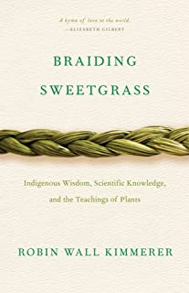
Our Friday Morning Book Study
resumes Friday October 8th at 10:00 am, on Zoom.

Our New book is: Braiding Sweetgrass: Indigenous Wisdom, Scientific Knowledge and the Teachings of Plants,
by Robin Wall Kimmerer.

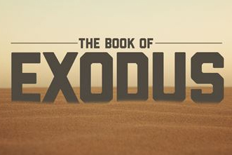

An Invitation to a Zoom Bible Study: The Book of Exodus, online, led by Rev. Kim at Mount Zion United Church

Rev. Kim Lawrence, serving at Mt. Zion United Church has invited Goodwood or Claremont United members who are interested to join them for their Zoom Bible study – this is a 6-week Bible Study which will explore the 2nd half of the Book of Exodus

Begins: Next Thursday October 14th
Time: 7-8 pm, on Zoom.

To join, email Rev. Kim Lawrence at: mountzionunitedchurch@gmail.com

Join us for Worship on our YouTube channel - CFG Worship
- Join us for worship either on Zoom, or on YouTube, Sundays at 10:30 am
- Watch past services uploaded to our YouTube channel
Go to Youtube.com and search CFG Worship.

Continued Financial Support

for our Congregations
Please prayerfully consider how you can continue to support
your congregation’s ongoing ministries during this time.

Offerings can be mailed to the church address itself:
PAR forms (for pre-authorized debit) are available from your church treasurer
You can send your offering by E-TRANSFER through your online banking. Here is where to send them:
For Claremont United send to: treasurercuc@outlook.com
For Goodwood United send to: goodwooductreasurer@gmail.com
Thank you for your continued support of our congregation’s ministry.

